503 (DA)
2023 PAPER
Question 1
1(a)
Suppose the weights of 800 male students are normally distributed with mean = 28.8 kg and standard deviation = 2.06 kg.
Find the number of students whose weights are:
i) Between 28.4 kg and 30.4 kg
ii) More than 31.3 kg
ans : 🔹 Important Formula (Z-score)
$$z=\frac{x-μ}{σ}$$

✅ (i) Number of students with weight between 28.4 kg and 30.4 kg
🔹 Step 1: Find z-score for 28.4 kg
$$z_{1}=\frac{28.4-28.8}{2.06}=\frac{-0.4}{2.06}≈-0.19$$

🔹 Step 2: Find z-score for 30.4 kg
$$z_{2}=\frac{30.4-28.8}{2.06}=\frac{1.6}{2.06}≈0.78$$

🔹 Step 3: Find area from Z-table
From standard normal table:
- Area between mean and $z=0.78$→ 0.2823
- Area between mean and $z=0.19$→ 0.0753
👉 Since one is negative and one positive, areas add hongi:
$$P(28.4<X<30.4)=0.2823+0.0753=0.3576$$

🔹 Step 4: Find number of students
$$\text{Students}=0.3576×800=286.08$$
✅ Answer (i):
$$\boxed{≈286\text{ students}}$$

✅ (ii) Number of students with weight more than 31.3 kg

🔹 Step 1: Find z-score for 31.3 kg
$$z=\frac{31.3-28.8}{2.06}=\frac{2.5}{2.06}≈1.21$$

🔹 Step 2: Find area from Z-table
- Area between mean and $z=1.21$→ 0.3869
👉 Area to the right side (more than 31.3):
$$P(X>31.3)=0.5-0.3869=0.1131$$

🔹 Step 3: Find number of students
$$\text{Students}=0.1131×800=90.48$$
✅ Answer (ii):
$$\boxed{≈90\text{ students}}$$

1(b)
A random variable has the following probability function:
x | 0 | 1 | 2 | 3 | 4 | 5 | 6 | 7
P(x) | 0 | K | 2K | 2K | 3K | K² | 2K² | 7K² + K
Determine:
i) k
ii) mean
iii) variance

Ans : 1️⃣ Random Variable kya hota hai?
Simple language me 👇
👉 Random Variable ek number hota hai jo kisi experiment ke result par depend karta hai.
Example:
- Coin toss
  - Head → 1
  - Tail → 0
👉 Yahan “number” result hai → random variable
Is question me:
- x = 0, 1, 2, 3, 4, 5, 6, 7
- Ye sab random variable ke possible values hain

2️⃣ Probability Function (P(x)) kya hota hai?
👉 Probability function batata hai:
“x ki value aane ki probability kitni hai”
Important rules (EXAM GOLD ⭐)
1️⃣ Har probability 0 aur 1 ke beech hoti hai
2️⃣ Sab probabilities ka sum = 1 hota hai
$$∑P(x)=1$$
⚠️ Ye rule har probability distribution me lagta hai

Yahan K ek unknown constant hai
👉 Pehla kaam hota hai K nikalna

K kaise nikalte hain? (Core Concept)
Rule yaad rakho 👇
$$∑P(x)=1$$
👉 Table ke saare P(x) ko add karo
👉 Unka sum 1 ke equal hona chahiye
👉 Isi se K niklega
⚠️ Ye step bina samjhe kabhi skip mat karna
Mean (Expected Value) kya hota hai?
Mean ko probability me bolte hain:
👉 Expected Value (E[X])
Formula:
$$\text{Mean}=E(X)=∑x⋅P(x)$$
Simple matlab 👇
“Average value jo long run me expect kar sakte hain”
Example:
- x ko P(x) se multiply
- Sab ko add
6️⃣ Variance kya hota hai?
👉 Variance batata hai:
“Values mean se kitni door-door faili hui hain”
Formula:
$$\text{Variance}=σ^{2}=E(X^{2})-[E(X)]^{2}$$
Jahan:
- $E(X^{2})=∑x^{2}⋅P(x)$
⚠️ Ye formula exam me bahut important hai

Solution :

Step 1: K nikaalna
Rule yaad hai:
$$∑P(x)=1$$
Table ke saare P(x) add karo:
$$0+K+2K+2K+3K+K^{2}+2K^{2}+(7K^{2}+K)=1$$
Combine like terms:
- K terms: $K+2K+2K+3K+K=9K$
- K² terms: $K^{2}+2K^{2}+7K^{2}=10K^{2}$
$$9K+10K^{2}=1$$
👉 Quadratic ban gayi:
$$10K^{2}+9K-1=0$$
Solve karne par (factorization/ formula se):
$$K=\frac{1}{10}(\text{negative value reject})$$
✅ K = 0.1

🔹 Step 2: Mean (E[X])
Formula:
$$E(X)=∑xP(x)$$
Ab K = 0.1 put karo:

x | P(x) | x·P(x)
0 | 0 | 0
1 | 0.1 | 0.1
2 | 0.2 | 0.4
3 | 0.2 | 0.6
4 | 0.3 | 1.2
5 | 0.01 | 0.05
6 | 0.02 | 0.12
7 | 0.17 | 1.19

$$E(X)=0.1+0.4+0.6+1.2+0.05+0.12+1.19=3.66$$
✅ Mean = 3.66

🔹 Step 3: Variance
Formula:
$$\text{Var}(X)=E(X^{2})-[E(X)]^{2}$$
Pehle $E(X^{2})$:

x | P(x) | $$x^{2}P(x)$$
1 | 0.1 | 0.1
2 | 0.2 | 0.8
3 | 0.2 | 1.8
4 | 0.3 | 4.8
5 | 0.01 | 0.25
6 | 0.02 | 0.72
7 | 0.17 | 8.33

$$E(X^{2})=16.8$$
Ab variance:
$$\text{Var}(X)=16.8-(3.66)^{2}=16.8-13.3956=3.40 (approx.)$$

Question 2
2(a)
A sales tax officer has reported that the average sales of 500 businesses during a year is Rs. 36,000 with a standard deviation of Rs. 10,000.
Assuming the sales are normally distributed, find:
i) The number of businesses whose sales are greater than Rs. 40,000
ii) The percentage of businesses whose sales are likely to range between Rs. 30,000 and Rs. 40,000
ans : 📘 Given Data
- Total businesses $N=500$
- Mean sales $μ=36,000$
- Standard deviation $σ=10,000$
- Distribution = Normal

🔑 Formula used (Z-score)
$$z=\frac{x-μ}{σ}$$

✅ (i) Number of businesses with sales greater than Rs. 40,000
🔹 Step 1: Find z-score for 40,000
$$z=\frac{40,000-36,000}{10,000}=\frac{4,000}{10,000}=0.40$$

🔹 Step 2: Z-table value
From Z-table (area between mean and z):
- For z = 0.40, area = 0.1554

🔹 Step 3: Area to the right of 40,000
Right side area:
$$0.5-0.1554=0.3446$$

🔹 Step 4: Number of businesses
$$0.3446×500=172.3$$
✅ Answer (i):
$$\boxed{≈172\text{ businesses}}$$

✅ (ii) Percentage of businesses with sales between Rs. 30,000 and Rs. 40,000

🔹 Step 1: Find z-score for 30,000
$$z_{1}=\frac{30,000-36,000}{10,000}=\frac{-6,000}{10,000}=-0.60$$

🔹 Step 2: Find z-score for 40,000
(already calculated)
$$z_{2}=0.40$$

🔹 Step 3: Z-table values
- For z = 0.60 → area = 0.2257
- For z = 0.40 → area = 0.1554
👉 One value left of mean, one right → areas add
$$0.2257+0.1554=0.3811$$

🔹 Step 4: Convert to percentage
$$0.3811×100=38.11\%$$
✅ Answer (ii):
$$\boxed{38.11\%\text{ businesses}}$$

🎯 FINAL ANSWERS (EXAM-READY)
1️⃣ Businesses with sales more than Rs. 40,000
$$\boxed{172\text{ (approximately)}}$$
2️⃣ Percentage of businesses with sales between Rs. 30,000 and Rs. 40,000
$$\boxed{38.11\%}$$

2(b)
Discuss the trends in Big Data generation and acquisition.
Ans :
🔹 Introduction
Big Data generation and acquisition ka matlab hai kaise huge amount of data create ho raha hai aur kaise us data ko collect, store aur process kiya ja raha hai. Aaj ke digital era me data har second generate ho raha hai from multiple sources.

🔹 Trends in Big Data Generation
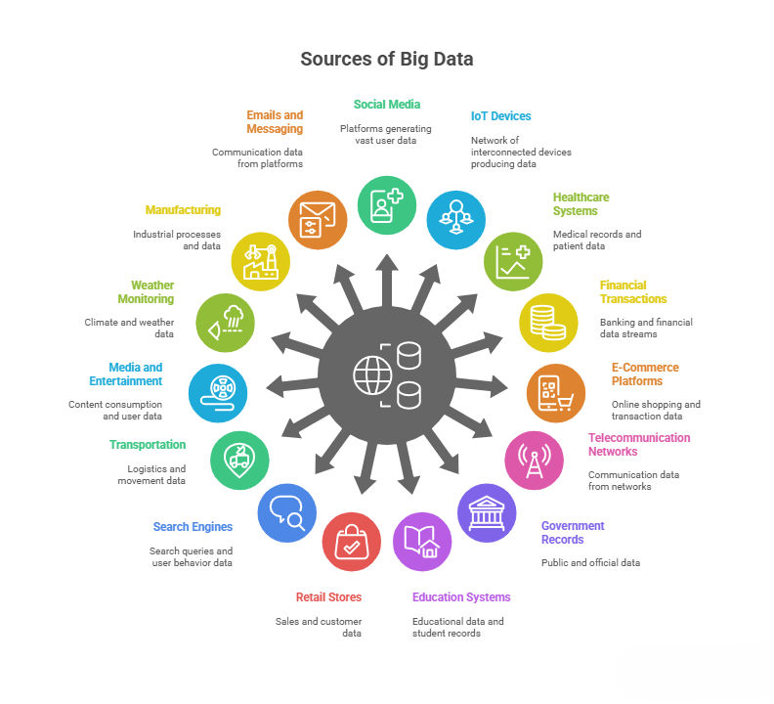
1️⃣ Explosion of Social Media Data
Platforms like Facebook, Instagram, Twitter par likes, shares, comments, videos aur images continuously data generate kar rahe hain.
2️⃣ Internet of Things (IoT)
Smart devices, sensors, wearables, smart homes aur smart cities real-time data produce kar rahe hain.
3️⃣ Mobile & App Usage Growth
Smartphones, mobile apps, GPS, online payments se massive data generate hota hai.
4️⃣ Multimedia Data Growth
Text ke saath-saath images, audio, video aur live streams ka use bahut badh gaya hai.
5️⃣ Machine & Log Data
Servers, networks, applications aur systems automatically logs aur machine data generate karte hain.

🔹 Trends in Big Data Acquisition
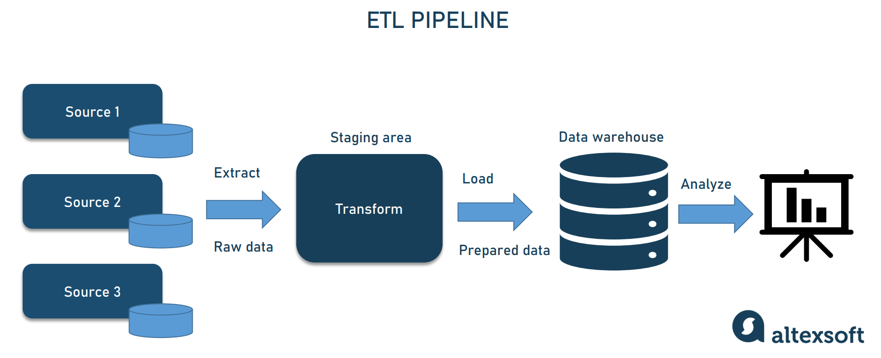

1️⃣ Real-Time Data Acquisition
Batch processing ke bajay real-time streaming data (sensor data, stock market, traffic data) ka use badh raha hai.
2️⃣ Cloud-Based Data Collection
Cloud platforms scalable, cost-effective aur fast data acquisition allow karte hain.
3️⃣ Integration of Multiple Data Sources
Structured, semi-structured aur unstructured data ko ek saath acquire kiya ja raha hai.
4️⃣ Automated Data Collection Tools
ETL tools, APIs, web crawlers aur data pipelines ka use increase hua hai.
5️⃣ Edge Data Acquisition
Data ko source ke paas hi collect aur pre-process kiya ja raha hai to reduce latency.

🔹 Conclusion
Big Data generation aur acquisition ke trends clearly show karte hain ki data faster, larger aur more complex ho raha hai. Isliye modern tools, cloud platforms aur real-time processing technologies ka use essential ho gaya hai.

Question 3
Explain the following: (Any FOUR)
a) Predictive Analytics
b) Inter- and Trans-firewall Analytics
c) Information Management
d) Crowd Sourcing Analytics

ans : a) Predictive Analytics

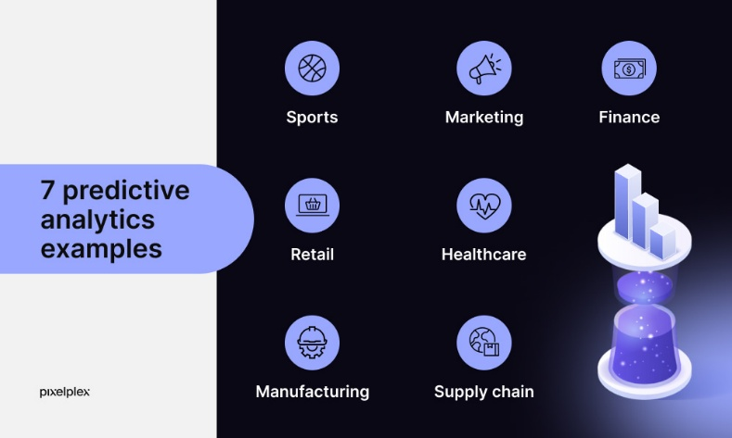

🔹 Definition
Predictive Analytics ek advanced analytics technique hai jisme historical aur current data ka use karke future events, trends, ya outcomes ka prediction kiya jata hai. Ye statistical models, machine learning aur data mining techniques par based hota hai.

🔹 Working / Process
- Data Collection
- Data Cleaning & Preparation
- Model Building (Regression, Classification, ML models)
- Prediction Generation
- Decision Making

🔹 Applications
- Sales & demand forecasting
- Fraud detection
- Healthcare diagnosis
- Customer behavior prediction
- Risk management

🔹 Advantages
- Better decision making
- Risk reduction
- Cost saving
- Competitive advantage

🔹 Conclusion
Predictive Analytics organizations ko future ko samajhne aur proactive decisions lene me madad karta hai, isliye Big Data Analytics ka ek important part hai.

Inter- and Trans-Firewall Analytics

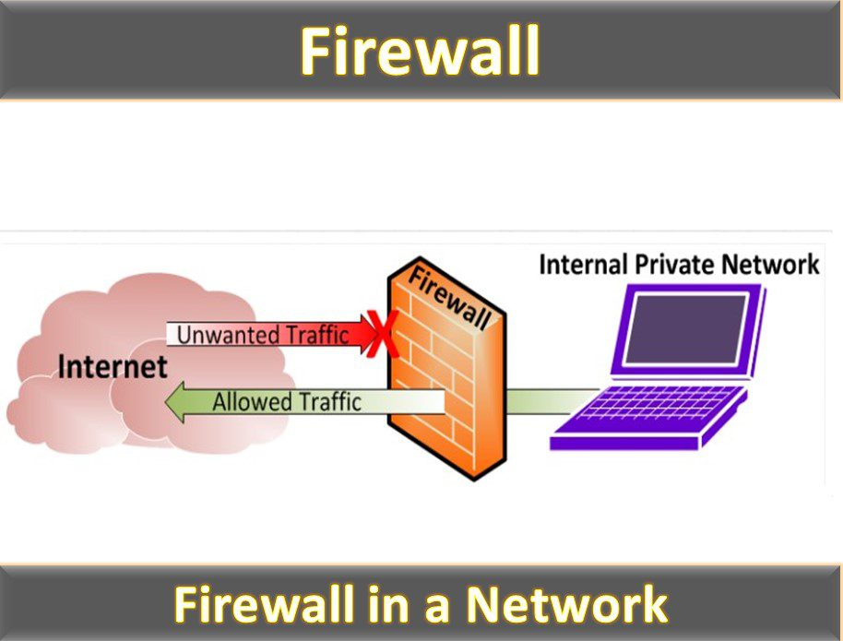

🔹 Definition
Inter- and Trans-Firewall Analytics ka matlab hai different firewalls ke across ya unke through data ka analysis karna. Isme secure networks ke beech aur bahar se aane wale data ko analyze kiya jata hai.

🔹 Inter-Firewall Analytics
- Different organizations ya departments ke multiple firewalls ke beech data analysis
- Example: Branch offices aur central server ke beech data analysis

🔹 Trans-Firewall Analytics
- Firewall ke through aane-jaane wale data ka analysis
- Example: Customer data jo internet se company ke system me aa raha hai

🔹 Importance
- Security monitoring
- Fraud detection
- Compliance management
- Cross-organization analytics

🔹 Challenges
- Data security issues
- Privacy concerns
- Data integration complexity

🔹 Conclusion
Inter- and Trans-Firewall Analytics organizations ko secure environment me bhi meaningful insights nikalne me help karta hai, bina security compromise kiye.

c) Information Management

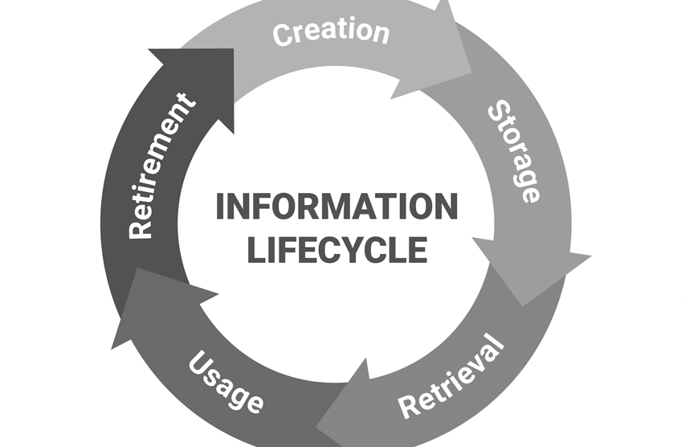
🔹 Definition
Information Management ek systematic process hai jisme data ko collect, organize, store, secure aur maintain kiya jata hai taaki sahi information sahi time par sahi logon tak pahunch sake.

🔹 Information Management Lifecycle
- Data Collection
- Data Storage
- Data Processing
- Data Security
- Data Retrieval
- Data Archiving / Disposal

🔹 Importance
- Improved decision making
- Better data quality
- Regulatory compliance
- Efficient information access

🔹 Role in Big Data
Big Data environment me Information Management large, diverse aur fast-moving data ko effectively handle karne me madad karta hai.

🔹 Conclusion
Information Management ensures karta hai ki organizations data ko valuable information me convert kar paayein aur business goals achieve kar saken.

d) Crowd Sourcing Analytics
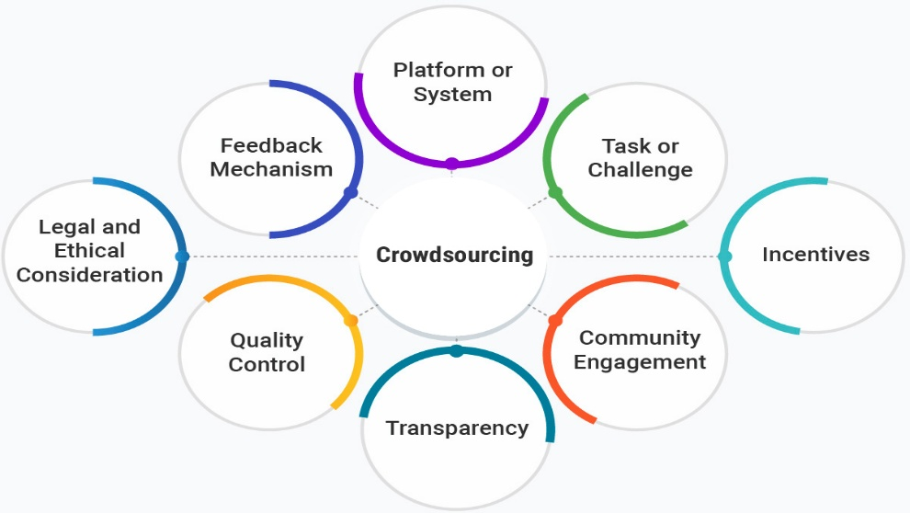
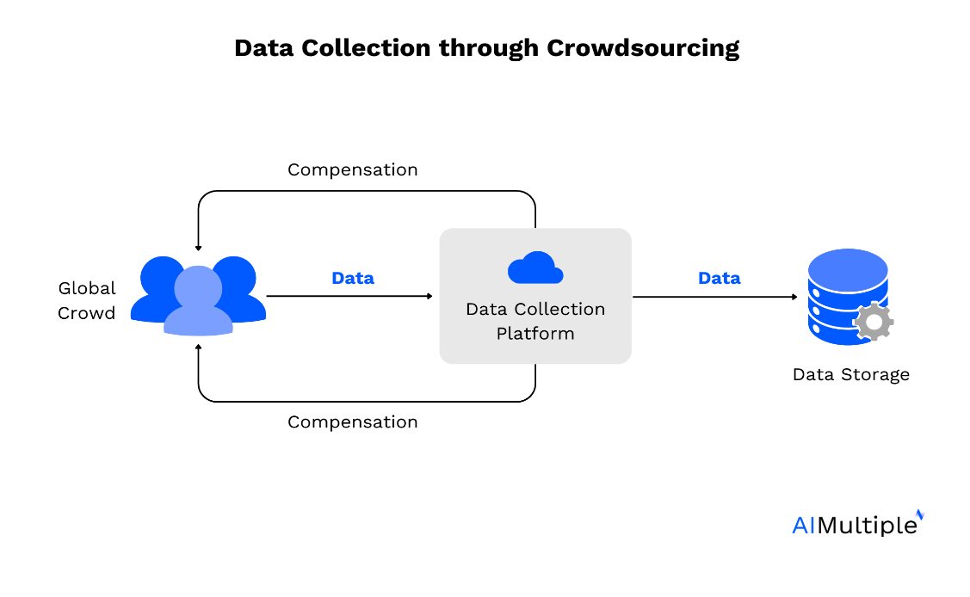

🔹 Definition
Crowd Sourcing Analytics ek technique hai jisme large group of people (crowd) se data, ideas ya solutions collect karke unka analysis kiya jata hai.

🔹 Working Process
- Problem Definition
- Crowd Engagement
- Data Collection
- Data Validation
- Data Analysis
- Insight Generation

🔹 Applications
- Market research
- Product feedback
- Traffic & navigation systems
- Social media analysis

🔹 Advantages
- Cost-effective
- Large-scale data collection
- Diverse opinions
- Faster insights

🔹 Challenges
- Data quality issues
- Privacy concerns
- Data reliability

🔹 Conclusion
Crowd Sourcing Analytics organizations ko real-world, large-scale insights provide karta hai jo traditional analytics se possible nahi hote.

Question 4
4(a)
With an example, explain the term Social Media Analytics.
Ans :
Definition
Social Media Analytics ka matlab hai social media platforms par users ke data (posts, likes, comments, shares, hashtags, videos) ko collect, analyze aur interpret karna, taaki user behavior, trends, opinions aur brand perception samjhi ja sake.
Ye Big Data Analytics ka ek important application hai kyunki social media se huge volume aur real-time data generate hota hai.

📊 Diagram: Social Media Analytics Flow
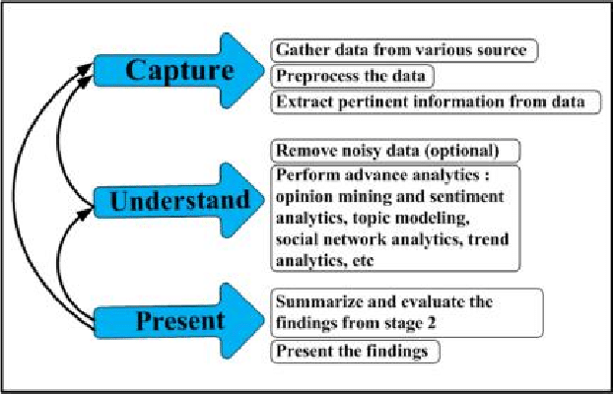

(Exam me simple flow diagram banao)
Social Media Data → Data Collection → Data Processing → Analytics → Insights / Decisions

🔹 Components of Social Media Analytics
1️⃣ Data Collection
Posts, comments, likes, shares, hashtags, images, videos collect kiye jate hain.
2️⃣ Data Processing
Unstructured data ko clean, filter aur organize kiya jata hai.
3️⃣ Analysis Techniques
- Sentiment Analysis
- Trend Analysis
- Network Analysis
4️⃣ Visualization & Insights
Graphs, dashboards aur reports ke through results dikhaye jate hain.

🔹 Example (Very Important for Exam)
👉 Example: Product Launch Analysis
Maan lo ek company ne new smartphone launch kiya.
Company Twitter aur Instagram se related hashtags aur comments collect karti hai.
- Positive comments → Product acceptance
- Negative comments → Issues / complaints
- Trending hashtags → Marketing success
Is analysis se company:
✔️ Customer feedback samajh sakti hai
✔️ Marketing strategy improve kar sakti hai
✔️ Product quality enhance kar sakti hai

🔹 Applications of Social Media Analytics
- Brand monitoring
- Customer sentiment analysis
- Market research
- Political campaigns
- Crisis management

🔹 Conclusion
Social Media Analytics organizations ko real-time public opinion aur user behavior samajhne me madad karta hai, jisse better decisions aur competitive advantage milta hai.

4(b)
What are the various stages in Big Data Analytics Life Cycle?
Illustrate with a figure, explaining each stage.
Ans :
Introduction
Big Data Analytics Life Cycle ek systematic process hai jisme raw data ko useful insights me convert kiya jata hai. Is life cycle ke through organizations data-driven decisions le paati hain.

📊 Figure: Big Data Analytics Life Cycle
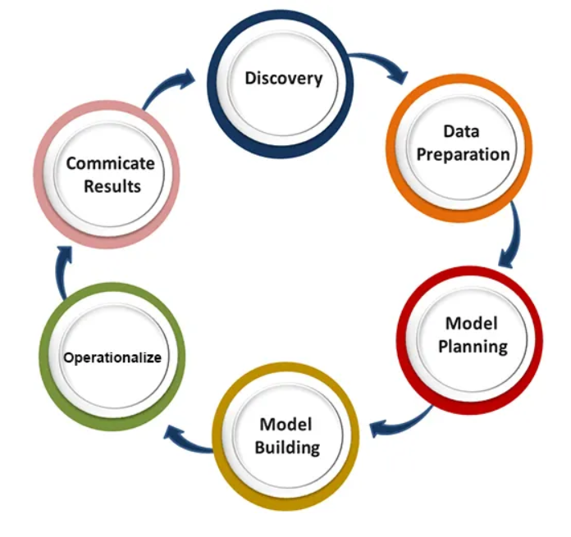

(Exam me simple circular diagram draw karo)
Data Generation → Data Acquisition → Data Storage → Data Processing → Data Analysis → Data Visualization → Decision Making

🔹 Stages of Big Data Analytics Life Cycle

1️⃣ Data Generation
Is stage me data different sources se generate hota hai jaise:
- Social media
- IoT sensors
- Mobile devices
- Transaction systems
👉 Data structured, semi-structured aur unstructured ho sakta hai.

2️⃣ Data Acquisition
Is stage me data ko collect aur ingest kiya jata hai.
- APIs
- Logs
- Streaming tools
- ETL processes
👉 Data real-time ya batch mode me acquire hota hai.

3️⃣ Data Storage
Collected data ko scalable storage systems me store kiya jata hai.
- HDFS
- Cloud storage
- NoSQL databases
👉 Storage reliable aur fault-tolerant hota hai.

4️⃣ Data Processing
Stored data ko clean, transform aur prepare kiya jata hai.
- Data cleaning
- Data transformation
- Data integration
👉 Hadoop MapReduce, Spark jaise frameworks use hote hain.

5️⃣ Data Analysis
Is stage me actual analytics perform hoti hai.
- Descriptive Analytics
- Predictive Analytics
- Prescriptive Analytics
👉 Patterns, trends aur relationships identify kiye jate hain.

6️⃣ Data Visualization
Analysis ke results ko charts, graphs aur dashboards ke form me present kiya jata hai.
- Easy understanding
- Quick interpretation

7️⃣ Decision Making
Final stage me insights ka use karke business decisions liye jate hain.
- Strategy planning
- Performance improvement
- Risk reduction

🔹 Conclusion
Big Data Analytics Life Cycle ensures karta hai ki large aur complex data ko efficiently handle karke meaningful insights nikale ja sakें, jo organizations ko competitive advantage dete hain.

Question 5
5(a)
Briefly explain the main components of MapReduce.
Ans :
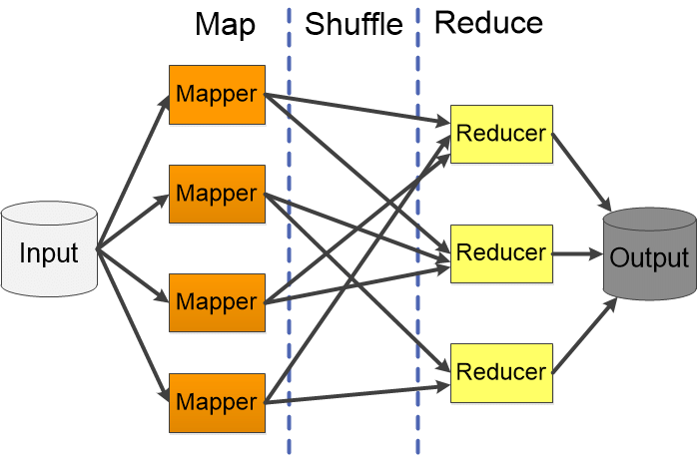
🔹 Introduction
MapReduce ek programming model aur processing framework hai jo large data sets ko distributed environment me parallel processing ke liye use hota hai. Ye Hadoop ka core processing engine hai.
(Exam me simple flow diagram banao)
Input Data → Mapper → Shuffle & Sort → Reducer → Output

🔹 Main Components of MapReduce
1️⃣ Input Data
- Raw data jo HDFS me store hota hai
- Data blocks me divide hota hai processing ke liye

2️⃣ Mapper
- Input data ko process karta hai
- Data ko key–value pairs me convert karta hai
- Filtering aur transformation ka kaam karta hai

3️⃣ Shuffle and Sort
- Same keys wale data ko group karta hai
- Mapper aur Reducer ke beech data transfer karta hai
- Ye process automatically hota hai

4️⃣ Reducer
- Shuffled data par final computation karta hai
- Aggregation aur summarization karta hai
- Final output generate karta hai

5️⃣ Output
- Processed result ko HDFS me store kiya jata hai
- Ye analysis ke liye use hota hai

🔹 Conclusion
MapReduce ke components milkar large-scale data ko efficiently, fault-tolerant aur scalable manner me process karte hain, jo Big Data Analytics ke liye essential hai.

5(b)
What is Hadoop?
Describe the role of Hadoop in Big Data Analytics.
Also explain the core components of Hadoop.
Ans :
Hadoop ek open-source framework hai jo large amount of data (Big Data) ko distributed environment me store aur process karne ke liye use hota hai.
Ye commodity hardware par kaam karta hai aur fault-tolerant, scalable aur cost-effective solution provide karta hai.

🔹 Role of Hadoop in Big Data Analytics
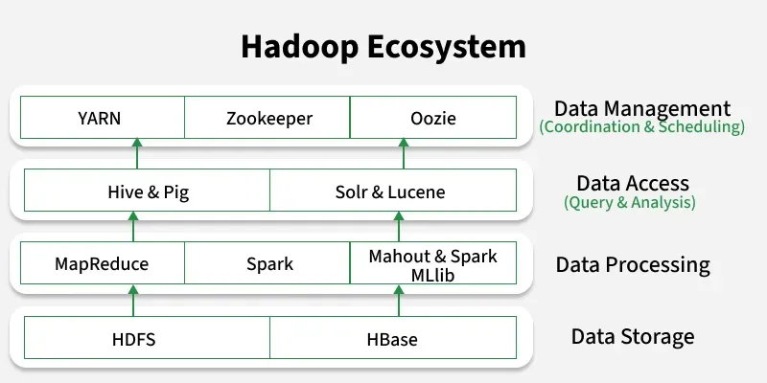

Hadoop Big Data Analytics me following roles play karta hai:
1️⃣ Storage of Big Data
- Huge structured aur unstructured data ko store karta hai using HDFS
2️⃣ Parallel Data Processing
- Data ko multiple nodes par divide karke fast processing karta hai
3️⃣ Scalability
- New nodes easily add karke storage aur processing power badhai ja sakti hai
4️⃣ Fault Tolerance
- Data replication ke through system failure ke baad bhi data safe rehta hai
5️⃣ Cost Effectiveness
- Low-cost hardware par kaam karta hai
👉 Isliye Hadoop Big Data Analytics ka backbone maana jata hai.

🔹 Core Components of Hadoop

1️⃣ HDFS (Hadoop Distributed File System)
- Data ko blocks me divide karke multiple machines par store karta hai
- Components:
  - NameNode
  - DataNode
- High reliability aur fault tolerance provide karta hai

2️⃣ MapReduce
- Data processing framework
- Do phases:
  - Map → data ko key-value pairs me convert karta hai
  - Reduce → final result generate karta hai

3️⃣ YARN (Yet Another Resource Negotiator)
- Cluster ke resources manage karta hai
- CPU, memory allocation karta hai
- Job scheduling ka kaam karta hai

4️⃣ Hadoop Common
- Hadoop ko support karne wali libraries aur utilities
- File system, I/O operations, configuration tools provide karta hai

🔹 Conclusion :
Hadoop Big Data Analytics ke liye ek powerful framework hai jo huge data ko efficiently store, process aur analyze karta hai. Uske core components milkar Hadoop ko scalable, reliable aur high-performance system banate hain.

Question 6
6(a)
Describe the structure of HDFS in a Hadoop ecosystem using a diagram.
Ans :
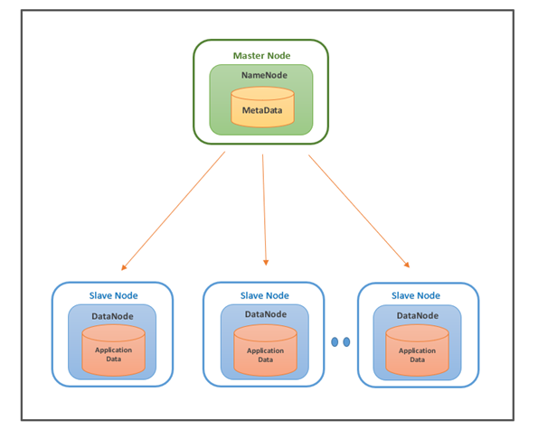
🔹 Introduction
HDFS (Hadoop Distributed File System) Hadoop ecosystem ka storage layer hai. Iska main purpose large data files ko distributed manner me store karna, high reliability ke saath. HDFS master–slave architecture follow karta hai.

🔹 Components of HDFS Structure

1️⃣ NameNode (Master Node)
- HDFS ka central controller hota hai
- File system ka metadata store karta hai
  - File names
  - Block locations
  - Access permissions
- Data actual me store nahi karta

2️⃣ DataNode (Slave Nodes)
- Actual data blocks store karte hain
- Client ke read/write requests handle karte hain
- Regularly NameNode ko heartbeat aur block reports bhejte hain

3️⃣ Secondary NameNode
- NameNode ka backup maintain karta hai
- Metadata ko periodically merge karta hai
- Ye standby NameNode nahi hota (important exam point)

4️⃣ HDFS Client
- User aur HDFS ke beech interface
- Read/write requests NameNode ke through initiate hoti hain

5️⃣ Data Blocks & Replication
- Files ko fixed-size blocks (default 128 MB) me tod diya jata hai
- Har block ka replication multiple DataNodes par hota hai
- Fault tolerance ensure hoti hai

🔹 Working (Short)
- Client pehle NameNode se metadata leta hai
- Data directly DataNodes se read/write hota hai
- NameNode sirf coordination karta hai

🔹 Conclusion
HDFS structure Hadoop ecosystem ko scalable, fault-tolerant aur reliable storage system provide karta hai, jo Big Data Analytics ke liye essential hai.

6(b)
Why is finding similar items important in Big Data?
Illustrate using two example applications.
Ans : 🔹 Introduction
Big Data me finding similar items ka matlab hai large datasets ke andar un objects, users, ya records ko identify karna jo ek-jaise features ya behavior share karte hain.
Ye process recommendation, prediction aur decision-making systems ka core part hota hai.

(Exam me simple diagram banao)
Big Data → Feature Extraction → Similarity Computation → Similar Items → Application Output

🔹 Why Finding Similar Items is Important in Big Data
1️⃣ Improved Recommendations
Similar items identify karke users ko relevant suggestions diye ja sakte hain.
2️⃣ Personalization
User ke past behavior ke basis par customized experience milta hai.
3️⃣ Pattern & Relationship Discovery
Large datasets me hidden patterns aur relationships easily milte hain.
4️⃣ Scalability in Analytics
Similarity techniques Big Data ko efficiently cluster aur organize karti hain.
5️⃣ Better Decision Making
Organizations ko accurate aur data-driven decisions lene me madad milti hai.

🔹 Example Applications

✅ Example 1: E-Commerce Recommendation System
👉 Scenario:
Amazon jaisi e-commerce website millions of products aur users ka data store karti hai.
👉 How similarity helps:
- User A ne Product X kharida
- System dekhta hai kaunse users ne Product X ke similar products kharide
- User A ko similar items recommend kiye jate hain
👉 Result:
- Sales increase
- Better user experience

✅ Example 2: Social Media Friend / Content Recommendation
👉 Scenario:
Social media platforms users ke likes, shares, comments aur follows ka data analyze karte hain.
👉 How similarity helps:
- Similar interests wale users identify kiye jate hain
- Similar posts, pages ya friends recommend kiye jate hain
👉 Result:
- Higher user engagement
- Relevant content delivery

🔹 Conclusion
Big Data me similar items find karna recommendation systems, personalization, clustering aur predictive analytics ke liye bahut important hai. Ye process user satisfaction badhata hai aur business value create karta hai.

Question 7
7(a)
Why choose Hadoop for processing Big Data?
Explain the concept of distributed and parallel computing challenges in detail.
Ans : 🔹 Introduction
Big Data ka size, speed aur complexity itni zyada hoti hai ki traditional systems ise efficiently process nahi kar paate. Hadoop ek open-source framework hai jo distributed aur parallel computing ka use karke Big Data ko effectively process karta hai.
1️⃣ Distributed Storage (HDFS)
- Data ko ek machine ke bajay multiple nodes par store karta hai
- Storage scalable aur reliable hoti hai
2️⃣ Parallel Processing (MapReduce)
- Data ko chhote parts me divide karke parallel processing karta hai
- Processing time kaafi kam ho jata hai
3️⃣ Scalability
- New nodes easily add karke system ko bada banaya ja sakta hai
4️⃣ Fault Tolerance
- Data replication ke kaaran node failure par bhi data safe rehta hai
5️⃣ Cost Effectiveness
- Commodity (low-cost) hardware par kaam karta hai
👉 In sab wajah se Hadoop Big Data processing ke liye best choice mana jata hai.

🔹 Concept of Distributed and Parallel Computing

🔸 Distributed Computing
Distributed computing me multiple independent computers (nodes) milkar ek hi task complete karte hain.
Har node apna local processing karta hai aur network ke through communicate karta hai.
Example:
Ek large file ko multiple machines par store aur process karna.

🔸 Parallel Computing
Parallel computing me same task ke multiple parts ek saath (simultaneously) execute hote hain, jisse processing fast hoti hai.
Example:
Data ko chunks me todkar sab chunks ko ek saath process karna.

🔹 Challenges in Distributed & Parallel Computing

1️⃣ Data Distribution Challenge
- Data ko nodes ke beech efficiently distribute karna difficult hota hai
- Unequal distribution se performance kam ho sakti hai

2️⃣ Fault Tolerance
- Nodes kisi bhi time fail ho sakte hain
- System ko automatically recover karna zaroori hota hai

3️⃣ Synchronization Issue
- Parallel tasks ke beech proper coordination chahiye
- Wrong synchronization se incorrect results aa sakte hain

4️⃣ Network Latency
- Nodes ke beech communication slow ho sakta hai
- High data transfer cost performance ko affect karti hai

5️⃣ Load Balancing
- Sab nodes par equal workload distribute karna mushkil hota hai

6️⃣ Data Consistency
- Distributed environment me data consistency maintain karna challenging hota hai

🔹 How Hadoop Handles These Challenges
- HDFS replication → Fault tolerance
- MapReduce framework → Parallel execution
- YARN → Resource & load management
- Data locality → Network traffic kam karta hai

🔹 Conclusion
Hadoop Big Data processing ke liye ideal hai kyunki ye distributed storage aur parallel processing ka use karke large data ko efficiently handle karta hai. Distributed aur parallel computing ke challenges ko Hadoop apni architecture ke through effectively solve karta hai.

7(b)
Explain in detail the interaction process with Hadoop Ecosystem.
List out various Big Data processing technologies.
Ans : 🔹 Introduction
Hadoop Ecosystem tools aur frameworks ka ek collection hai jo Big Data ko store, process, analyze aur manage karne ke liye milkar kaam karte hain. In tools ke beech ka interaction process data analytics ko scalable aur efficient banata hai.

(Exam me simple layered diagram banao)
Data Sources → Ingestion → Storage (HDFS) → Processing → Analytics → Visualization

🔹 Interaction Process with Hadoop Ecosystem (Step-by-Step)

1️⃣ Data Sources
Data multiple sources se aata hai:
- Social media
- Sensors / IoT
- Logs
- Databases
👉 Data structured, semi-structured ya unstructured ho sakta hai.

2️⃣ Data Ingestion
Data Hadoop me laane ke liye ingestion tools use hote hain:
- Flume → log & streaming data
- Sqoop → relational databases se data
👉 Is stage par data HDFS ke liye prepare hota hai.

3️⃣ Data Storage (HDFS)
- Data ko HDFS me distributed manner me store kiya jata hai
- Data blocks aur replication ke through fault tolerance milti hai

4️⃣ Resource Management (YARN)
- YARN cluster resources manage karta hai
- CPU aur memory allocation karta hai
- Multiple jobs ko efficiently schedule karta hai

5️⃣ Data Processing Layer
- MapReduce / Spark data ko parallel process karte hain
- Data transformation, aggregation aur computation hota hai

6️⃣ Data Access & Analytics
High-level tools data analysis ko easy banate hain:
- Hive → SQL-like queries
- Pig → Data flow language

7️⃣ Workflow & Coordination
- Oozie jobs aur workflows manage karta hai
- Complex pipelines ko automate karta hai

8️⃣ Monitoring & Management
- ZooKeeper → coordination services
- Ambari → cluster monitoring & administration

9️⃣ Visualization & Decision Making
- Processed data ko dashboards, reports aur graphs me convert kiya jata hai
- Final insights business decisions ke liye use hote hain

🔹 List of Various Big Data Processing Technologies
✅ Batch Processing
- Hadoop MapReduce
- Apache Spark
✅ Stream / Real-Time Processing
- Apache Storm
- Apache Flink
- Spark Streaming
✅ Query & Analytics
- Apache Hive
- Apache Pig
✅ NoSQL Databases
- HBase
- Cassandra
- MongoDB
✅ Data Ingestion
- Apache Flume
- Apache Sqoop

🔹 Conclusion
Hadoop Ecosystem ka interaction process dikhata hai ki kaise different tools milkar Big Data ka complete life cycle handle karte hain — from data ingestion to analytics and decision making. Multiple processing technologies Hadoop ko flexible, scalable aur powerful banati hain.

Question 8
8(a)
Explain Pig Data Model in detail and discuss how it helps in effective data flow.
Ans : 🔹 Introduction
Apache Pig ek high-level data flow platform hai jo Hadoop par large datasets ko process karne ke liye use hota hai. Pig Data Model define karta hai ki Pig Latin me data kaise represent, store aur flow karta hai during processing.
Iska main goal hai complex Big Data processing ko simple aur efficient banana.

📊 Diagram: Pig Data Model & Data Flow
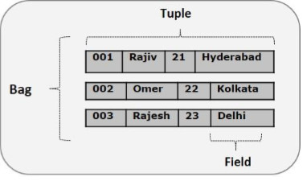
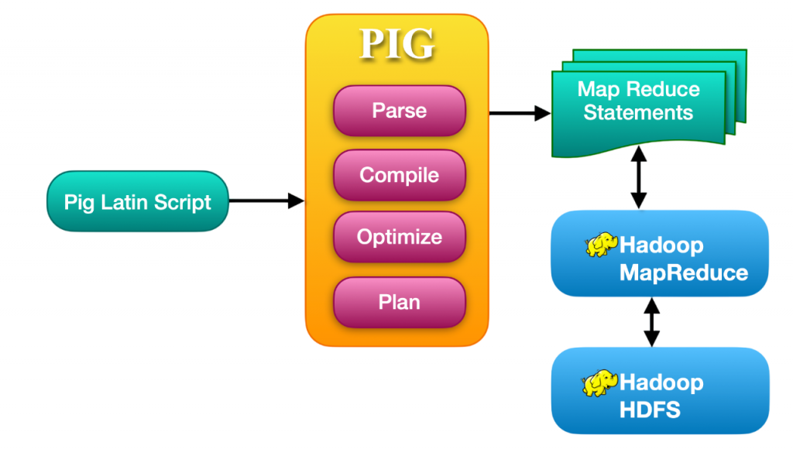

(Exam me simple diagram banao)
HDFS Data → Pig Latin Script → Logical Plan → Physical Plan → MapReduce Jobs → Output

🔹 Pig Data Model (In Detail)
Pig ka data model rich and flexible hota hai, jo structured aur semi-structured data dono ko support karta hai.

1️⃣ Atom
- Data ka smallest unit
- Single value hoti hai
- Example:
- 10, "Delhi", 85.5

2️⃣ Tuple
- Ordered collection of atoms
- Similar to a row in a table
- Represented using parentheses ()
Example:
(101, "Rahul", 45000)

3️⃣ Bag
- Collection of tuples
- Duplicate tuples allowed
- Unordered structure
- Represented using { }
Example:
{(101, "Rahul", 45000), (102, "Amit", 48000)}

4️⃣ Map
- Key–value pairs ka collection
- Keys always string type hoti hain
- Represented using [ ]
Example:
[name#Rahul, city#Delhi]

5️⃣ Relation
- Bag of tuples ka logical name
- Pig Latin operations relations par apply hote hain
Example:
employees = LOAD 'emp.txt';

🔹 How Pig Data Model Helps in Effective Data Flow

1️⃣ Schema Flexibility
- Pig supports schema-on-read
- Data ko bina strict schema ke load kiya ja sakta hai
👉 Semi-structured data ke liye ideal

2️⃣ Simple Data Flow Programming
- Pig Latin procedural language hai
- Step-by-step data flow define hota hai
👉 Complex MapReduce coding ki zarurat nahi

3️⃣ Handles Complex Data Types Easily
- Bags, tuples aur maps se nested data easily process hota hai
👉 Real-world Big Data ke liye perfect

4️⃣ Automatic Optimization
- Pig internally logical plan ko physical plan me convert karta hai
- Automatically MapReduce jobs generate karta hai
👉 Developer ko optimization ki tension nahi

5️⃣ Parallel Execution
- Pig scripts Hadoop cluster par parallel run hoti hain
👉 High performance aur scalability

6️⃣ Improved Productivity
- Kam lines of code
- Easy debugging aur testing
👉 Fast development & maintenance

🔹 Conclusion
Pig Data Model Big Data ko flexible, scalable aur easy-to-process format me represent karta hai. Iske rich data structures aur data-flow based approach se efficient data processing aur faster analytics possible hoti hai, jo Hadoop ecosystem me Pig ko ek powerful tool banata hai.

8(b)
Draw and explain the architecture of Apache Hive.
Explain various data insertion techniques in Hive with example.
Ans :
🔹 Introduction
Apache Hive Hadoop ecosystem ka ek data warehouse tool hai jo large datasets par SQL-like queries (HiveQL) run karne ke liye use hota hai. Hive internally queries ko MapReduce / Tez / Spark jobs me convert karta hai.

📊 Diagram: Architecture of Apache Hive

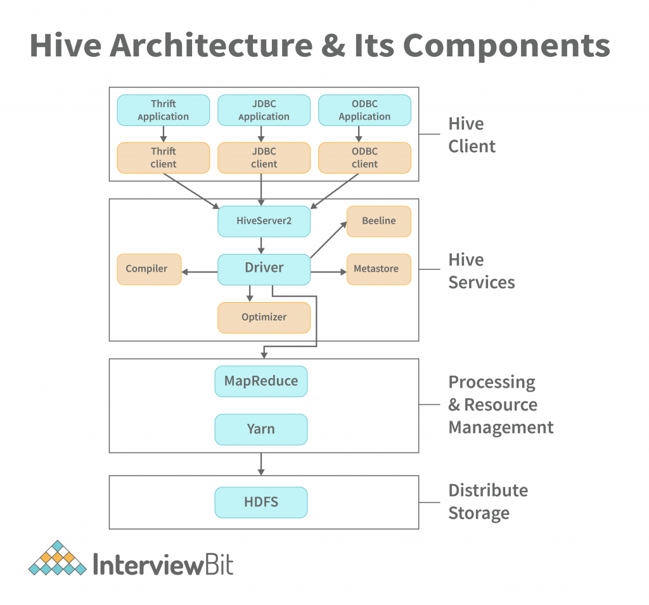
(Exam me simple diagram is tarah banao)
User / Client
|
HiveQL
|
Hive Driver
|
Compiler → Optimizer → Executor
|
Metastore
|
Hadoop (HDFS + MapReduce)

🔹 Components of Apache Hive Architecture
1️⃣ User Interface (UI)
- User HiveQL queries likhta hai
- Interfaces: CLI, Web UI, JDBC/ODBC

2️⃣ Hive Driver
- Query execution ko control karta hai
- Query lifecycle manage karta hai

3️⃣ Compiler
- HiveQL ko parse karta hai
- Query plan generate karta hai

4️⃣ Optimizer
- Query plan ko optimize karta hai
- Execution cost kam karta hai

5️⃣ Executor
- Query plan ko Hadoop jobs me convert karta hai
- MapReduce / Spark jobs execute karta hai

6️⃣ Metastore
- Table schema, partitions, location store karta hai
- Metadata management karta hai

7️⃣ Hadoop Layer
- HDFS → Data storage
- MapReduce / Spark → Data processing

🔹 Data Insertion Techniques in Hive (With Examples)

🔹 1️⃣ INSERT INTO TABLE
➡ Existing data ko append karta hai
INSERT INTO TABLE student
VALUES (101, 'Rahul', 85);
📌 Purane data ke saath new data add hota hai.

🔹 2️⃣ INSERT OVERWRITE TABLE
➡ Table ka purana data delete karke new data insert karta hai
INSERT OVERWRITE TABLE student
SELECT * FROM student_temp;
📌 Data refresh ke liye use hota hai.

🔹 3️⃣ LOAD DATA INPATH
➡ HDFS ya local file se data load karta hai
LOAD DATA INPATH '/user/data/students.txt'
INTO TABLE student;
📌 Fast loading technique.

🔹 4️⃣ LOAD DATA LOCAL INPATH
➡ Local system se data load karta hai
LOAD DATA LOCAL INPATH '/home/user/students.txt'
INTO TABLE student;

🔹 5️⃣ INSERT INTO TABLE … SELECT
➡ Ek table se data leke dusre table me insert karta hai
INSERT INTO TABLE passed_students
SELECT * FROM student WHERE marks > 40;

🔹 Conclusion
Apache Hive architecture Hadoop par efficient querying aur data warehousing provide karti hai. Alag-alag data insertion techniques Hive ko flexible aur powerful banati hain, jo Big Data analytics me bahut useful hai.

PAPER – 2020 DEC

Q1 a) What is Big Data? Explain characteristics of Big Data.
Ans : Big Data ka matlab hai aisa data jo bahut zyada quantity me, bahut tez speed se, aur different formats me generate hota hai, jise traditional data processing tools efficiently handle nahi kar paate.
Is data ko process aur analyze karne ke liye special technologies jaise Hadoop, Spark etc. ka use kiya jata hai.
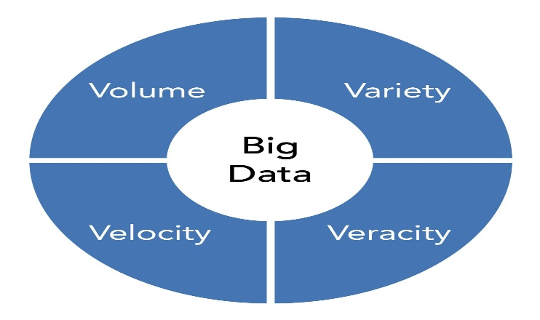

Characteristics of Big Data (V’s of Big Data)

1️⃣ Volume
- Data ki quantity bahut zyada hoti hai (TBs, PBs, ZBs)
- Sources: social media, sensors, transactions
👉 Example: Facebook par daily petabytes of data generate hota hai.

2️⃣ Velocity
- Data bahut tez speed se generate aur process hota hai
- Real-time ya near real-time processing required
👉 Example: Stock market data, live sensor data.

3️⃣ Variety
- Data different formats me hota hai
  - Structured (tables)
  - Semi-structured (XML, JSON)
  - Unstructured (text, images, videos)

4️⃣ Veracity
- Data ki quality aur reliability
- Noisy, incomplete ya inconsistent data ho sakta hai
👉 Accurate analysis ke liye data cleaning zaroori hoti hai.

5️⃣ Value
- Data tabhi useful hota hai jab usse meaningful insights nikale ja sakें
- Business decisions me value add karta hai
👉 Example: Customer behavior analysis se sales increase hoti hai.

🔹 Conclusion
Big Data modern digital world ka backbone hai. Iski characteristics—Volume, Velocity, Variety, Veracity aur Value—traditional systems ke liye challenge create karti hain, jise handle karne ke liye Big Data technologies ka use kiya jata hai.

b) Differentiate between Apache Pig and Map Reduce.
Ans: Basic Idea (1–2 lines for intro)
Apache Pig ek high-level data flow tool hai jo Big Data processing ko simple banata hai, jabki MapReduce ek low-level programming model hai jo distributed environment me data process karta hai.
(Exam me simple likho)
Pig Latin → Pig Engine → MapReduce Jobs → Output

🔹 Difference between Apache Pig and MapReduce
Basis | Apache Pig | MapReduce
Level | High-level tool | Low-level programming model
Language | Pig Latin (easy & readable) | Java / Python (complex)
Coding Effort | Very less code | Large amount of code
User Type | Data analysts | Developers / programmers
Development Speed | Fast development | Slow development
Execution | Converts Pig Latin to MapReduce | Directly executes Map & Reduce
Optimization | Automatic optimization | Manual optimization required
Data Flow | Procedural (step-by-step) | Functional (Map → Reduce)
Error Handling | Easy debugging | Debugging is difficult
Use Case | ETL, data analysis | Complex, customized processing

🔹 Example (Very Helpful in Exam)
🔸 Apache Pig Example
data = LOAD 'sales.txt';
result = GROUP data BY product;
STORE result INTO 'output';
👉 Simple, readable, less time

🔸 MapReduce Example (Concept)
- Write Mapper class
- Write Reducer class
- Handle key-value pairs
- Compile & run job
👉 Complex, time-consuming

🔹 Conclusion
Apache Pig Big Data processing ko easy, fast aur analyst-friendly banata hai, jabki MapReduce powerful but complex hai. Pig internally MapReduce ka use karta hai, isliye Pig ko MapReduce ka abstraction layer bhi kaha jata hai.

Q2 a) Explain replication and scaling features of Mongo DB.
Ans: 🔹 What is MongoDB?
MongoDB ek NoSQL, document-oriented database hai jo data ko JSON-like documents (BSON format) me store karta hai.
Ye schema-less, flexible, scalable aur high-performance database hai, jo Big Data aur real-time applications ke liye widely use hota hai.
👉 MongoDB traditional relational databases ka alternative hai jab data large, unstructured ya semi-structured ho.

🔹 Key Features of MongoDB
- Document-based storage
- Schema flexibility
- High performance
- Horizontal scalability
- Built-in replication & sharding

🔹 Replication in MongoDB
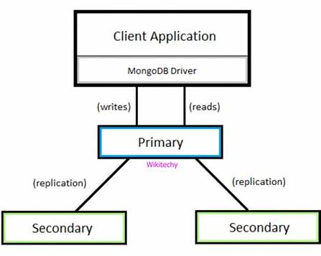

🔸 What is Replication?
Replication ka matlab hai same data ko multiple servers par copy karke rakhna, taaki high availability aur fault tolerance ensure ho.

🔸 Replica Set Architecture
MongoDB replication Replica Set ke through achieve hoti hai.
Components:
- Primary Node
  - Read & write operations handle karta hai
- Secondary Node(s)
  - Primary se data copy karta hai
  - Read operations support karta hai
- Arbiter (Optional)
  - Data store nahi karta
  - Election process me help karta hai

🔸 Working of Replication
- Primary node data update karta hai
- Changes Oplog ke through secondary nodes tak pahunchte hain
- Primary fail ho jaye → automatic failover hota hai

🔸 Advantages of Replication
- High availability
- Data safety
- Automatic failover
- Disaster recovery

🔹 Scaling in MongoDB
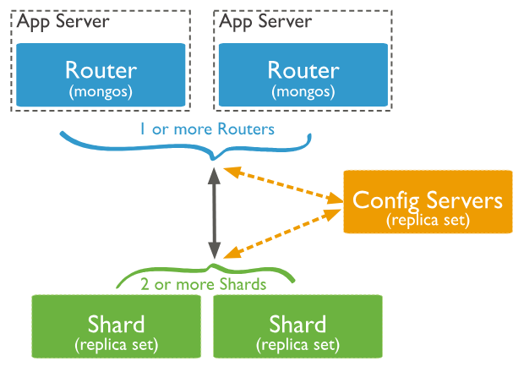
🔸 What is Scaling?
Scaling ka matlab hai database ki capacity aur performance badhana.
MongoDB mainly horizontal scaling support karta hai using Sharding.

🔸 Sharding in MongoDB
Sharding data ko multiple machines (shards) par distribute karta hai.
Components of Sharding:
- Shard – Actual data store karta hai
- Config Server – Metadata store karta hai
- Query Router (mongos) – Client requests ko route karta hai

🔸 How Sharding Works
- Data ko shard key ke basis par split kiya jata hai
- Har shard data ka ek portion store karta hai
- Queries parallel execute hoti hain

🔸 Advantages of Scaling (Sharding)
- Handles massive data volumes
- High performance
- Load distribution
- Easy horizontal expansion

🔹 Replication vs Scaling (One-Line Difference)
- Replication → Data safety & availability
- Scaling (Sharding) → Performance & capacity

🔹 Conclusion
MongoDB ek powerful NoSQL database hai jo replication ke through high availability aur sharding ke through scalable architecture provide karta hai. Ye features MongoDB ko Big Data applications aur real-time systems ke liye ideal choice banate hain.

b) Write down the goals of HDFS.
Ans :

HDFS (Hadoop Distributed File System) ka main goal hai Big Data ko efficiently, reliably aur economically store karna. Iske major goals niche diye gaye hain:

🔹 Goals of HDFS
1️⃣ Store Very Large Files
HDFS ko huge data files (GBs to TBs/PBs) store karne ke liye design kiya gaya hai.

2️⃣ High Fault Tolerance
Data ko multiple DataNodes par replicate kiya jata hai, taaki node failure hone par bhi data safe rahe.

3️⃣ High Throughput Access
HDFS high-speed data access provide karta hai, jo Big Data analytics ke liye suitable hota hai.

4️⃣ Scalability
HDFS me naye nodes easily add kiye ja sakte hain bina system ko stop kiye.

5️⃣ Cost-Effective Storage
HDFS commodity (low-cost) hardware par kaam karta hai, isliye economical solution hai.

6️⃣ Distributed Storage
Data ko single machine ke bajay multiple machines par store kiya jata hai.

7️⃣ Data Locality Support
Processing ko data ke paas le jaya jata hai, jisse network traffic kam hota hai aur performance badhti hai.

8️⃣ Simple Consistency Model
HDFS write-once, read-many access model follow karta hai, jo Big Data processing ke liye ideal hai.

🔹 Conclusion
HDFS ke goals Big Data ko reliable, scalable, fault-tolerant aur high-performance storage system me convert karna hai, jo Hadoop ecosystem ka backbone hai.

3. a) Define term frequency and inverse document frequency.
Ans:
Term Frequency (TF)
Term Frequency batata hai ki koi specific term (word) kisi document me kitni baar appear hota hai.
✔️ Definition
Term Frequency ek measure hai jo kisi document me ek term ki importance ko show karta hai.
✔️ Formula
$$TF(t,d)=\frac{\text{Number of times term }t\text{ appears in document }d}{\text{Total number of terms in document }d}$$
✔️ Example
Agar document me total 100 words hain aur word “data” 5 baar aata hai:
$$TF=\frac{5}{100}=0.05$$

🔹 Inverse Document Frequency (IDF)
Inverse Document Frequency batata hai ki koi term kitne documents me appear hota hai aur uski overall importance kya hai.
✔️ Definition
IDF ek measure hai jo common words ko kam weight aur rare words ko zyada weight deta hai.
✔️ Formula
$$IDF(t)=log⁡\left(\frac{N}{n_{t}}\right)$$
Where:
- $N$= Total number of documents
- $n_{t}$= Number of documents jisme term $t$appear hota hai
✔️ Example
Agar total documents = 1000
Aur term “analytics” sirf 10 documents me aata hai:
$$IDF=log⁡\left(\frac{1000}{10}\right)=log⁡(100)=2$$

🔹 Why TF–IDF is Important?
TF–IDF dono ko combine karke:
- Important keywords identify kiye jate hain
- Text mining aur information retrieval me use hota hai

🔹 Conclusion
- TF → term ki document ke andar importance
- IDF → term ki collection me rarity
- TF–IDF → term ka overall importance score
b) Explain 5 P’s of Big data in brief
ans :
1️⃣ People
People ka matlab hai data ko handle, analyze aur interpret karne wale log.
Isme data scientists, analysts, engineers aur decision-makers aate hain.
👉 Right people = right insights.

2️⃣ Process
Process wo steps aur workflows hote hain jinke through data collect, clean, store aur analyze hota hai.
👉 Well-defined process se data analytics efficient aur reliable banti hai.

3️⃣ Platform
Platform se matlab hai technologies aur tools jo Big Data ko process karte hain.
👉 Examples: Hadoop, Spark, Hive, NoSQL databases.
Ye scalability aur performance provide karte hain.

4️⃣ Performance
Performance batata hai ki system kitni speed aur efficiency se data process karta hai.
👉 Fast processing = real-time insights = better decisions.

5️⃣ Purpose
Purpose ka matlab hai Big Data use karne ka objective.
👉 Business growth, customer satisfaction, cost reduction, better decision making.

🔹 Conclusion
5 P’s of Big Data — People, Process, Platform, Performance aur Purpose — milkar Big Data Analytics ko successful aur meaningful banate hain.

4. a) What is H Base? Explain storage mechanism of H Base with an example
Ans:
🔹 What is HBase?
HBase (Hadoop Database) ek NoSQL, column-oriented, distributed database hai jo HDFS ke upar build hota hai.
Ye very large tables (billions of rows, millions of columns) ko real-time read/write access ke saath handle kar sakta hai.
👉 HBase Google ke BigTable model par based hai aur Big Data applications ke liye use hota hai.

🔹 Key Features of HBase
- Column-oriented storage
- Schema-less & flexible
- Real-time read/write
- Horizontally scalable
- Runs on HDFS (fault tolerant)
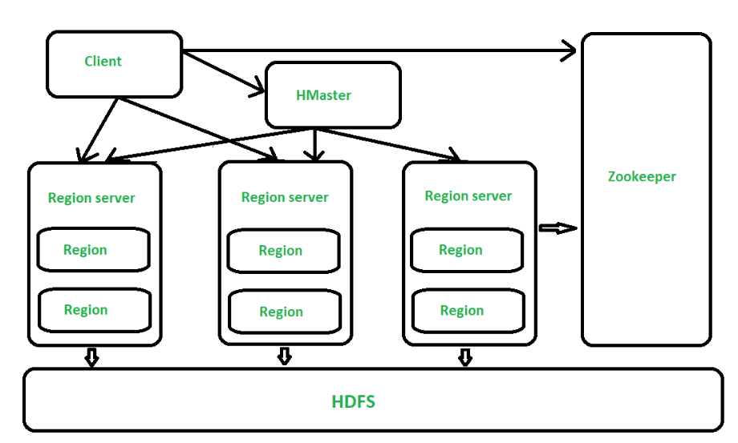
(Exam me simple block diagram banao)
Client → HBase (Table → Column Families) → Region → Store → HFiles (HDFS)

🔹 Storage Mechanism of HBase (In Detail)
HBase data ko tables ke form me store karta hai, lekin traditional RDBMS se kaafi different way me.

1️⃣ Table
- HBase table rows aur columns se milkar banti hai
- Har row ka ek unique Row Key hota hai

2️⃣ Row Key
- Table ki primary identifier
- Rows lexicographical order me store hoti hain
👉 Fast data access ke liye important

3️⃣ Column Family
- Columns ko column families me group kiya jata hai
- Physically data column family ke basis par store hota hai
📌 Example:
personal, academic, contact

4️⃣ Column Qualifier
- Column family ke andar actual column name
- Dynamically add ho sakta hai

5️⃣ Cell
- Smallest unit of storage
- Combination of:
Row Key + Column Family + Column Qualifier + Timestamp + Value

6️⃣ Regions
- Table ko horizontal partitions (regions) me divide kiya jata hai
- Har region ek RegionServer handle karta hai

7️⃣ HFiles (On HDFS)
- Actual data HFiles me store hota hai
- Ye files HDFS par persist hoti hain

🔹 Example: Student Table in HBase
🔸 Table: student
Row Key | personal:name | personal:age | academic:branch | academic:cgpa
S101 | Rahul | 21 | CSE | 8.5
S102 | Aman | 22 | IT | 8.1
👉
- personal aur academic = Column Families
- name, age, branch, cgpa = Column Qualifiers

🔹 How Storage Works (Step-by-Step)
- Data client se HBase ko aata hai
- Row Key ke basis par region select hota hai
- Data column family ke according store hota hai
- Finally data HFiles on HDFS me save hota hai

🔹 Conclusion
HBase ek powerful NoSQL database hai jo large-scale, real-time Big Data storage provide karta hai. Iska column-oriented aur distributed storage mechanism ise high performance, scalable aur fault-tolerant banata hai.

b) Explain the concept of metastore in Hive.
Ans:
🔹 Introduction
Metastore Apache Hive ka ek central metadata repository hota hai jisme Hive tables se related schema information store hoti hai.
Hive Metastore bina actual data ko store kiye, data ke baare me information (metadata) maintain karta hai.
(Exam me simple flow diagram banao)
HiveQL Query → Hive Driver → Metastore → Hadoop (HDFS)

🔹 What does Hive Metastore Store?
Hive Metastore following information store karta hai:
- Database names
- Table names
- Column names & data types
- Table location in HDFS
- Partition & bucket information
- Table properties (managed / external)
👉 Actual data HDFS me hota hai, Metastore sirf metadata rakhta hai.

🔹 Components of Hive Metastore
1️⃣ Metastore Database
- Metadata ko store karta hai
- Backend DB hota hai (MySQL, Derby, Oracle etc.)

2️⃣ Metastore Service
- Hive aur database ke beech bridge
- Metadata ko access/update karta hai

3️⃣ Hive Client
- Jab user query run karta hai, Hive client Metastore se schema details leta hai

🔹 Role of Metastore in Query Processing
- User HiveQL query run karta hai
- Hive Driver Metastore se table schema fetch karta hai
- Query validate hoti hai
- Execution plan banta hai
- Data HDFS se process hota hai
👉 Metastore ke bina Hive queries execute nahi ho sakti.

🔹 Types of Hive Metastore Deployment
1️⃣ Embedded Metastore
- Single-user environment
- Testing ke liye suitable
2️⃣ Local Metastore
- Hive service aur Metastore same machine par
- Database alag hota hai
3️⃣ Remote Metastore
- Multi-user production environment
- Best performance & scalability

🔹 Advantages of Hive Metastore
- Centralized metadata management
- Faster query execution
- Schema consistency
- Multi-user support

🔹 Conclusion
Hive Metastore Apache Hive ka backbone hai jo metadata management provide karta hai. Ye Hive ko data ko efficiently query aur manage karne me madad karta hai, bina actual data ko move kiye.

5. a) How can we extract data for data storage
Ans :
?

🔹 Introduction
Data extraction ka matlab hai different data sources se data collect karke use storage systems (databases, data warehouses, HDFS, cloud storage) me store karna.
Big Data environment me data structured, semi-structured aur unstructured ho sakta hai, isliye multiple extraction techniques use ki jaati hain.
(Exam me simple flow diagram banao)
Data Sources → Data Extraction → Data Transformation → Data Storage

🔹 Ways to Extract Data for Data Storage

1️⃣ Database Extraction
- Relational databases (MySQL, Oracle, SQL Server) se data extract kiya jata hai
- SQL queries ya tools ka use hota hai
👉 Example:
SELECT * FROM student;
📌 Mostly structured data ke liye use hota hai.

2️⃣ ETL (Extract, Transform, Load) Process
- Extract → Source se data nikalna
- Transform → Clean, format, filter karna
- Load → Storage me save karna
👉 Used in data warehouses & Big Data systems.

3️⃣ Log File Extraction
- Server logs, application logs, system logs se data extract kiya jata hai
- Mostly unstructured data hota hai
📌 Tools: Flume, Logstash

4️⃣ API-Based Data Extraction
- Web services aur applications se data APIs ke through liya jata hai
- JSON / XML format me data milta hai
👉 Example: Social media data extraction

5️⃣ Streaming Data Extraction
- Real-time data continuously extract hota hai
- Sensors, IoT devices, stock market data
📌 Tools: Kafka, Spark Streaming

6️⃣ Web Scraping
- Websites se data automatically extract kiya jata hai
- HTML pages se text, images, tables nikaale jate hain
📌 Used for market research & analytics

7️⃣ File-Based Extraction
- CSV, TXT, XML, JSON files se data extract kiya jata hai
- Files local system ya HDFS par ho sakti hain

🔹 Data Storage After Extraction
Extracted data ko store kiya ja sakta hai in:
- HDFS
- Cloud Storage
- Data Warehouse
- NoSQL Databases

🔹 Conclusion
Data extraction Big Data Analytics ka first aur most important step hai. Different extraction techniques ka use karke data ko efficiently collect karke storage systems me store kiya jata hai, jisse aage analysis possible hota hai.

b) What is Map Reduce programming model? Explain.
Ans : paper 2023
6. a) Explain Hadoop architecture and its components with proper diagram.
Ans :
Introduction
Hadoop Architecture ek distributed architecture hai jo Big Data ko store aur process karne ke liye design ki gayi hai.
Ye architecture master–slave model par based hoti hai aur large-scale data ko scalable, fault-tolerant aur cost-effective way me handle karti hai.
🔹 Main Components of Hadoop Architecture
Hadoop architecture mainly 4 core components par based hoti hai:

1️⃣ HDFS (Hadoop Distributed File System)
➡ Storage Layer
- Big Data ko distributed manner me store karta hai
- Files ko blocks me todkar multiple machines par store karta hai
- Fault tolerance ke liye data replication use karta hai
🔸 HDFS Components:
- NameNode → Metadata store karta hai
- DataNode → Actual data blocks store karta hai
- Secondary NameNode → Metadata backup maintain karta hai

2️⃣ MapReduce
➡ Processing Layer
- Data ko parallel manner me process karta hai
- Do phases:
  - Map → Data ko key–value pairs me convert karta hai
  - Reduce → Final result generate karta hai
👉 Large datasets ko efficiently process karta hai.

3️⃣ YARN (Yet Another Resource Negotiator)
➡ Resource Management Layer
- Cluster ke CPU, memory aur resources manage karta hai
- Multiple jobs ko schedule karta hai
🔸 YARN Components:
- ResourceManager → Central controller
- NodeManager → Each node ke resources manage karta hai
- ApplicationMaster → Job execution handle karta hai

4️⃣ Hadoop Common
➡ Utilities & Libraries Layer
- Hadoop ke liye required common libraries provide karta hai
- File system, I/O operations aur configuration support deta hai

🔹 Working of Hadoop Architecture (Brief Flow)
- Client data HDFS me upload karta hai
- HDFS data ko blocks me todkar DataNodes par store karta hai
- MapReduce job submit hota hai
- YARN resources allocate karta hai
- MapReduce parallel processing karta hai
- Output HDFS me store hota hai

B )What is Zoo keeper? List the benefits of it.
Ans :
What is ZooKeeper?
Apache ZooKeeper ek centralized coordination service hai jo distributed systems me configuration management, synchronization aur naming services provide karta hai.
Ye Hadoop ecosystem aur other distributed applications ko reliable coordination me help karta hai.
👉 ZooKeeper ka main kaam hai:
Distributed systems ke components ko coordinated, consistent aur synchronized rakhna.
(Exam me simple likho)
Clients ↔ ZooKeeper Ensemble ↔ Distributed Applications

🔹 Benefits of ZooKeeper
1️⃣ Centralized Coordination
ZooKeeper distributed applications ke liye single coordination point provide karta hai.

2️⃣ Configuration Management
Configuration information ko centrally store aur manage karta hai, jo sab nodes ko accessible hoti hai.

3️⃣ High Availability
ZooKeeper replicated servers (ensemble) use karta hai, isliye single server failure se system down nahi hota.

4️⃣ Synchronization
Multiple nodes ke beech synchronization aur locking mechanism provide karta hai.

5️⃣ Naming Service
Distributed environment me services ko unique names assign karne me help karta hai.

6️⃣ Fault Tolerance
Automatic failure detection aur recovery support karta hai.

7️⃣ Consistency Guarantee
ZooKeeper strong consistency maintain karta hai across distributed nodes.

8️⃣ Simplifies Distributed Applications
Complex distributed logic ko simple banata hai, jisse developers ka kaam easy ho jata hai.

🔹 Use of ZooKeeper in Hadoop Ecosystem
- HBase master coordination
- YARN resource coordination
- Leader election
- Cluster management

🔹 Conclusion
ZooKeeper distributed systems ka backbone hai jo coordination, synchronization aur consistency provide karta hai. Iske benefits Hadoop jaise large-scale Big Data systems ko stable, reliable aur scalable banate hain.

7.a) Explain any three Hive QL DDL command with its syntax and example
ans :
1️⃣ CREATE TABLE
🔸 Purpose
CREATE TABLE command ka use Hive me nayi table banane ke liye hota hai.
🔸 Syntax
CREATE TABLE table_name (
column1 datatype,
column2 datatype
);
🔸 Example
CREATE TABLE student (
id INT,
name STRING,
marks INT
);
👉 Ye command student naam ki table banata hai Hive me.

🔹 2️⃣ DROP TABLE
🔸 Purpose
DROP TABLE command ka use existing table ko permanently delete karne ke liye hota hai.
🔸 Syntax
DROP TABLE table_name;
🔸 Example
DROP TABLE student;
👉 Isse student table aur uska metadata delete ho jata hai.

🔹 3️⃣ ALTER TABLE
🔸 Purpose
ALTER TABLE command ka use existing table ki structure modify karne ke liye hota hai
(jaise column add/remove/rename).
🔸 Syntax (Add Column)
ALTER TABLE table_name ADD COLUMNS (
column_name datatype
);
🔸 Example
ALTER TABLE student ADD COLUMNS (
age INT
);
👉 Isse student table me naya column age add ho jata hai.

🔹 (Extra for Impression ⭐)
TRUNCATE TABLE (Optional mention)
Table ka data delete karta hai, structure nahi.
TRUNCATE TABLE student;

🔹 Conclusion
HiveQL DDL commands jaise CREATE, DROP aur ALTER database structure ko manage karne ke liye use hote hain. Ye commands Hive me tables aur schema ko efficiently control karne me madad karte hain.

b) Write down the process of installing and running Hive.
Ans : Introduction
Apache Hive Hadoop ecosystem ka ek data warehousing tool hai jo HDFS par stored data ko SQL-like language (HiveQL) ke through query karne ki facility deta hai. Hive ko run karne ke liye Hadoop properly installed hona zaroori hota hai.
(Exam me simple flow diagram banao)
User → HiveQL → Hive Driver → Hadoop (HDFS + MapReduce/Spark) → Output

🔹 Process of Installing Hive

1️⃣ Install Java (JDK)
Hive Java par based hota hai, isliye Java install hona compulsory hai.
java -version

2️⃣ Install Hadoop
Hive HDFS aur MapReduce/Spark par kaam karta hai, isliye Hadoop pehle install aur configure kiya jata hai.
hadoop version

3️⃣ Download and Extract Hive
Apache Hive ko official site se download karke extract kiya jata hai.
tar -xvf apache-hive-x.x.x-bin.tar.gz

4️⃣ Set Environment Variables
HIVE_HOME aur PATH set kiya jata hai.
export HIVE_HOME=/usr/local/hive
export PATH=$PATH:$HIVE_HOME/bin

5️⃣ Configure Hive
- hive-site.xml file configure ki jati hai
- Metastore database (Derby / MySQL) setup kiya jata hai
schematool -initSchema -dbType derby

🔹 Process of Running Hive

6️⃣ Start Hadoop Services
Hive chalane se pehle Hadoop services start honi chahiye.
start-dfs.sh
start-yarn.sh

7️⃣ Launch Hive Shell
Hive interactive mode me start hota hai.
hive

8️⃣ Create Database and Table
HiveQL ka use karke database aur table banayi jati hai.
CREATE DATABASE college;
USE college;

CREATE TABLE student(
id INT,
name STRING,
marks INT
);

9️⃣ Load Data into Hive Table
LOAD DATA INPATH '/user/data/student.txt'
INTO TABLE student;

🔟 Run Hive Queries
SELECT * FROM student;
Hive internally query ko MapReduce / Spark job me convert karke execute karta hai.

🔹 Conclusion
Hive installation aur execution ek systematic process follow karta hai jisme Java aur Hadoop setup ke baad Hive configure karke HiveQL queries run ki jati hain. Ye process Hive ko Big Data analytics ke liye powerful aur user-friendly tool banata hai.

8.Write short note on any three of the following.
I )Pig latin
Ans :
🔹 Meaning
Pig Latin Apache Pig ki high-level data flow language hai, jo Hadoop par large datasets ko process karne ke liye use hoti hai.
🔹 Key Points
- Procedural language (step-by-step data flow)
- MapReduce ke upar abstraction provide karti hai
- Less coding, easy to learn
- Structured aur semi-structured data handle karti hai
🔹 Example
data = LOAD 'student.txt';
result = FILTER data BY marks > 40;
STORE result INTO 'output';
🔹 Use
ETL operations, data cleaning, transformation aur analysis ke liye use hoti hai.
Pig Latin ki 3 Important Commands

1️⃣ LOAD
🔹 Use
HDFS ya local file se data load karne ke liye.
🔹 Syntax
relation = LOAD 'filepath' USING PigStorage(',')
AS (field1:type, field2:type);
🔹 Example
student = LOAD 'student.txt' USING PigStorage(',')
AS (id:int, name:chararray, marks:int);

2️⃣ FILTER
🔹 Use
Condition ke basis par required records select karne ke liye.
🔹 Syntax
relation2 = FILTER relation BY condition;
🔹 Example
passed = FILTER student BY marks > 40;

3️⃣ STORE
🔹 Use
Processed data ko HDFS me store karne ke liye.
🔹 Syntax
STORE relation INTO 'output_path';
🔹 Example
STORE passed INTO 'passed_students';

2) Information management
3 )Sharding process
Ans :
Sharding ek database scaling technique hai jisme large data ko chhote-chhote parts (shards) me tod kar multiple servers par distribute kiya jata hai.

🔹 How Sharding Works
- Data ko shard key ke basis par divide kiya jata hai
- Har shard data ka ek portion store karta hai
- Queries parallel execute hoti hain

🔹 Benefits
- High scalability
- Better performance
- Load balancing
- Handles massive data volume

🔹 Example
User data ko User_ID ke basis par different servers me store karna.

🔹 Conclusion
Sharding Big Data systems ko horizontally scale karne ka powerful method hai, jo performance aur capacity dono badhata hai.

4) SPARK
Apache Spark ek open-source, distributed Big Data processing framework hai jo large datasets ko very fast speed se process karta hai.
Spark ka biggest advantage hai in-memory processing, jiski wajah se ye Hadoop MapReduce se 10–100 times faster hota hai.
Spark batch processing ke saath-saath real-time streaming, machine learning aur graph processing ko bhi support karta hai.
Components of Apache Spark
1️⃣ Spark Core
- Basic processing engine
- Task scheduling aur memory management
2️⃣ Spark SQL
- Structured data ke liye
- SQL-like queries support karta hai
3️⃣ Spark Streaming
- Real-time data processing ke liye
- Live data streams handle karta hai
4️⃣ MLlib
- Machine Learning library
- Classification, clustering, regression algorithms
5️⃣ GraphX
- Graph processing ke liye
- Social network analysis me useful

🔹 Advantages of Apache Spark
- Very high processing speed
- In-memory computation
- Supports batch + streaming
- Easy APIs (Python, Scala, Java)
- Fault tolerant
- Less coding required

🔹 Apache Spark vs Hadoop MapReduce (Short)
Apache Spark | Hadoop MapReduce
In-memory processing | Disk-based processing
Very fast | Slower
Supports real-time | Batch only
Less code | More code

🔹 Applications of Apache Spark
- Real-time analytics
- Fraud detection
- Recommendation systems
- Machine learning
- Log analysis

🔹 Conclusion
Apache Spark Big Data analytics ke liye ek powerful, fast aur flexible framework hai. In-memory processing aur multiple analytics support ki wajah se Spark modern Big Data applications ka preferred choice ban chuka hai.

5) 4 V’s of Big dat
(Exam me ek circle ya box ke beech “Big Data” likho aur charon taraf V’s banao)

🔹 1️⃣ Volume
- Data ki bahut badi matra (quantity) ko Volume kehte hain
- Big Data me data GBs, TBs, PBs tak hota hai
👉 Example: Social media platforms par roz petabytes of data generate hota hai.

🔹 2️⃣ Velocity
- Data kis speed se generate aur process hota hai, use Velocity kehte hain
- Real-time ya near real-time processing required hoti hai
👉 Example: Stock market data, live sensor data.

🔹 3️⃣ Variety
- Data ke different formats ko Variety kehte hain
- Types:
  - Structured (tables)
  - Semi-structured (JSON, XML)
  - Unstructured (text, images, videos)
👉 Example: Emails, videos, social media posts.

🔹 4️⃣ Veracity
- Data ki quality, accuracy aur reliability ko Veracity kehte hain
- Big Data me data noisy ya incomplete ho sakta hai
👉 Example: Fake reviews, incorrect sensor data.

🔹 Conclusion
Big Data ki main characteristics — Volume, Velocity, Variety aur Veracity — traditional systems ke liye challenge create karti hain. Inhe handle karne ke liye Hadoop, Spark jaise Big Data tools use kiye jate hain.

PAPER – 2020 DEC
1. a) What are the benefits of Big Data?
Discuss challenges under Big Data.
Ans :
🔹 Introduction
Big Data ka matlab hai bahut zyada volume, high speed aur different formats ka data.
Is data ka proper analysis organizations ko better decisions, predictions aur efficiency provide karta hai, lekin saath hi kuch challenges bhi aate hain.

🔹 Benefits of Big Data
1️⃣ Better Decision Making
Big Data analytics se organizations data-driven decisions le sakti hain, jo accurate aur reliable hote hain.

2️⃣ Improved Customer Experience
Customer behavior, preferences aur feedback analyze karke personalized services provide ki ja sakti hain.

3️⃣ Cost Reduction
Big Data tools jaise Hadoop aur Spark low-cost storage aur processing provide karte hain, jisse operational cost kam hoti hai.

4️⃣ Real-Time Analytics
Big Data se real-time data analysis possible hota hai, jo quick actions aur alerts generate karta hai.

5️⃣ Innovation & New Opportunities
Big Data se new business models, products aur services develop ki ja sakti hain.

6️⃣ Risk Management & Fraud Detection
Patterns aur anomalies detect karke fraud aur risks ko pehle hi identify kiya ja sakta hai.

7️⃣ Operational Efficiency
Processes ko optimize karke performance aur productivity improve hoti hai.

🔹 Challenges under Big Data
1️⃣ Data Storage & Management
Big Data ka size bahut bada hota hai, jise store aur manage karna difficult hota hai.

2️⃣ Data Quality (Veracity)
Data incomplete, noisy ya inconsistent ho sakta hai, jo wrong analysis ka reason ban sakta hai.

3️⃣ Data Security & Privacy
Sensitive data ko protect karna ek major challenge hai, especially cyber attacks ke against.

4️⃣ High Processing Complexity
Large aur complex data ko process karne ke liye powerful systems aur tools chahiye.

5️⃣ Skilled Professionals ki Kami
Big Data tools aur analytics ke liye trained experts easily available nahi hote.

6️⃣ Integration Challenge
Different sources se aane wale data ko integrate karna mushkil hota hai.

7️⃣ Cost of Infrastructure
Initial setup me hardware, software aur maintenance cost zyada hoti hai.

🔚 Conclusion (Exam-Ready)
Big Data analytics organizations ko better insights, efficiency aur competitive advantage deta hai.
Lekin storage, security, quality aur skill-related challenges ko overcome karna zaroori hai taaki Big Data ka full benefit liya ja sake.

1. b) Explain CRUD operations in Mongo DB.
Ans : already done in important topics

2. a) How Big Data analytics can be useful in development of smart cities?
(Discuss one application).
Ans : 🔹 Introduction
Smart City ka aim hota hai technology aur data ka use karke urban services ko efficient, safe aur citizen-friendly banana.
Smart cities me sensors, IoT devices, cameras, GPS, mobile apps se huge amount of data generate hota hai.
Is data ko analyze karne ke liye Big Data Analytics ka use hota hai.
👉 Exam line:
“Big Data Analytics smart cities me real-time data ko analyze karke better planning aur decision making me madad karta hai.”

🔹 Application: Smart Traffic Management System ⭐
🔸 Problem in Cities
- Traffic congestion
- Long travel time
- Accidents
- Pollution

🔸 Role of Big Data Analytics
Smart traffic management me Big Data analytics ka use is tarah hota hai:
1️⃣ Data Collection
Data aata hai:
- Traffic sensors
- CCTV cameras
- GPS devices
- Mobile apps

2️⃣ Data Processing & Analysis
- Real-time traffic flow analysis
- Peak hours identify karna
- Accident-prone areas detect karna
Big Data tools (Hadoop, Spark) large data ko fast process karte hain.

3️⃣ Smart Decision Making
- Traffic signals automatically adjust ho jate hain
- Alternative routes suggest kiye jate hain
- Emergency vehicles ko priority milti hai

🔸 Benefits of This Application
- Traffic congestion kam hota hai
- Travel time reduce hota hai
- Fuel consumption & pollution kam hota hai
- Road safety improve hoti hai

🔹 Impact on Smart City Development
- Better urban mobility
- Improved quality of life
- Efficient use of resources
- Environment friendly city

🔚 Conclusion (Exam-Ready)
Big Data Analytics smart cities ke development me important role play karta hai. Smart traffic management jaise applications ke through cities zyada efficient, safe aur sustainable banti hain. Isliye Big Data Analytics smart city planning ka backbone hai.

2. b) What do you mean by inter and trans firewall analytics?
Ans :
🔹 Introduction
Organizations ke data sources firewalls ke andar (internal systems) aur firewalls ke bahar (external sources) hote hain.
Big Data Analytics me in dono jagah ke data ko analyze karne ke concepts ko Inter-Firewall Analytics aur Trans-Firewall Analytics kaha jata hai.

🔹 Inter-Firewall Analytics
🔸 Meaning
Inter-Firewall Analytics ka matlab hai organization ke internal firewalls ke andar available data ka analysis.
👉 Ye analytics internal systems par focus karta hai.

🔸 Data Sources
- Internal databases
- ERP systems
- CRM systems
- Internal logs

🔸 Purpose
- Business performance analysis
- Operational efficiency improve karna
- Internal decision making

🔸 Example
Company apne sales database aur employee performance data ka analysis karti hai taaki productivity improve ho.

🔹 Trans-Firewall Analytics
🔸 Meaning
Trans-Firewall Analytics ka matlab hai firewall ke bahar se aane wale external data ka analysis.
👉 Isme organization ke bahar ke data sources shamil hote hain.

🔸 Data Sources
- Social media
- Customer reviews
- Web logs
- Market data

🔸 Purpose
- Customer behavior samajhna
- Market trends analyze karna
- Competitive intelligence

🔸 Example
Company Twitter, Facebook reviews aur online feedback analyze karke customer sentiment samajhti hai.

🔹 Inter vs Trans Firewall Analytics (Short Difference)
Basis | Inter-Firewall | Trans-Firewall
Data Location | Firewall ke andar | Firewall ke bahar
Data Type | Internal enterprise data | External public data
Focus | Operations & performance | Customers & market
Risk Level | Low security risk | High security & privacy risk

🔚 Conclusion (Exam-Ready)
Inter-Firewall Analytics internal enterprise data par focus karta hai jabki Trans-Firewall Analytics external data sources ka analysis karta hai. Dono milkar organizations ko complete business insights aur better decision making provide karte hain.

3. a) Explain the process of data storage in Hadoop Distributed File System (HDFS) with the help of a suitable example.
Ans :
1️⃣ What is HDFS? (1–2 lines for intro)
HDFS Hadoop ka distributed storage system hai jo very large files ko multiple machines (nodes) par store karta hai with fault tolerance and high throughput.
Ye Master–Slave architecture follow karta hai.

🔹 2️⃣ HDFS Architecture (Detail me)
🔸 Master Node
✅ NameNode
- File system ka metadata manage karta hai
- Store karta hai:
  - File names
  - Block locations
  - Permissions
- Actual data store nahi karta
✅ Secondary NameNode
- NameNode ka helper hota hai
- Metadata ka periodic backup (checkpoint) banata hai
⚠️ Standby NameNode nahi hota (important exam point)

🔸 Slave Nodes
✅ DataNode
- Actual data blocks store karta hai
- Client ke read/write requests handle karta hai
- Regularly NameNode ko:
  - Heartbeat
  - Block Report bhejta hai

🔸 Client
- User ka interface HDFS ke saath
- Read/Write request initiate karta hai

🔸 Data Blocks & Replication
- File ko fixed-size blocks me tod diya jata hai
  - Default block size = 128 MB
- Har block ki replicas multiple DataNodes par hoti hain
  - Default replication factor = 3

🔹 3️⃣ Goals of HDFS (Exam me direct points)
1️⃣ Store Very Large Files (GBs–TBs–PBs)
2️⃣ Fault Tolerance (Replication ke through)
3️⃣ High Throughput Access (Analytics ke liye best)
4️⃣ Scalability (New nodes easily add)
5️⃣ Cost Effective (Commodity hardware)
6️⃣ Distributed Storage (Single machine limit nahi)
7️⃣ Data Locality (Processing data ke paas)
8️⃣ Write Once, Read Many Model (Simple consistency)
👉 Ye 6–8 points likhne se full marks.

🔹 4️⃣ Data Storage Process in HDFS (Step-by-Step)
📝 HDFS Write Process (Data kaise store hota hai)
1️⃣ Client NameNode ko request bhejta hai (file create karne ke liye)
2️⃣ NameNode metadata create karta hai
3️⃣ File ko blocks (128 MB) me divide kiya jata hai
4️⃣ NameNode decide karta hai:
- Kaunse DataNodes par blocks store honge
5️⃣ Client data direct DataNodes ko bhejta hai
6️⃣ Har block ki replicas different nodes par store hoti hain
7️⃣ DataNodes confirmation bhejte hain
8️⃣ NameNode metadata update karta hai
📌 Actual data flow: Client → DataNodes
📌 Metadata flow: Client ↔ NameNode

📝 HDFS Read Process (Short)
1️⃣ Client NameNode se block locations poochta hai
2️⃣ Client nearest DataNode se data read karta hai
3️⃣ NameNode sirf guide karta hai

🔹 5️⃣ Diagram (Exam Me Kaise Banaye)
Client
|
NameNode
(Metadata Manager)
|
--------------------------------
| | |
DataNode DataNode DataNode
(Block + Rep) (Block + Rep) (Block + Rep)
👉 Diagram me ye words likhna zaroori:
- NameNode (Metadata)
- DataNode (Blocks)
- Replication

🔹 6️⃣ Example (Very Important ⭐)
📂 Example: 300 MB File Upload
- File size = 300 MB
- Block size = 128 MB
👉 File break hogi:
- Block 1 → 128 MB
- Block 2 → 128 MB
- Block 3 → 44 MB
👉 Replication factor = 3
So:
- Total blocks stored = 3 × 3 = 9 blocks
- Different DataNodes par store honge
✔️ Agar ek DataNode fail ho jaye → data safe rahega

🔹 7️⃣ Why HDFS is Best for Big Data?
- Huge data handle karta hai
- Failure se data loss nahi
- Parallel processing support
- Hadoop ecosystem ka backbone

🔚 Conclusion (2 lines)
HDFS Hadoop ka core storage layer hai jo large-scale data ko reliable, scalable aur fault-tolerant way me store karta hai. Iski architecture aur data storage mechanism Big Data analytics ke liye perfect hai.

3. b) Explain the 4 V’s of Big Data.
Ans : already done

4. a) Explain the architecture and features of Hive.
Ans : already done
4. b) Justify: SPARK is faster than Map Reduce.
Ans :
1️⃣ In-Memory Processing (Main Reason)
- Spark data ko RAM me process karta hai
- MapReduce har step ke baad data disk me likhta aur padhta hai
👉 Less disk I/O = High speed

2️⃣ No Repeated Disk Read/Write
- Spark intermediate data ko memory me cache karta hai
- MapReduce me har Map aur Reduce ke baad disk access hota hai
👉 Spark me processing continuous hoti hai

3️⃣ DAG (Directed Acyclic Graph) Execution
- Spark tasks ko optimized DAG ke form me execute karta hai
- MapReduce me fixed flow hota hai (Map → Reduce)
👉 DAG = Better optimization + less steps

4️⃣ RDD (Resilient Distributed Dataset)
- Spark ka core data structure
- Distributed, immutable aur fault-tolerant
👉 Data reuse fast hota hai (especially ML jobs)

5️⃣ Supports Iterative Algorithms
- Machine Learning aur graph algorithms me multiple iterations hoti hain
- Spark me data memory me rehta hai
- MapReduce me har iteration me disk access hota hai
👉 Isliye ML me Spark 10–100x faster

6️⃣ Less Overhead
- Spark me job startup aur scheduling overhead kam hota hai
- MapReduce me har job ke liye heavy overhead hota hai

🔹 One-Line Justification (Exam Best)
“Spark MapReduce se faster hai kyunki Spark in-memory processing aur DAG-based execution ka use karta hai, jabki MapReduce disk-based processing karta hai.”

5. a) What is Apache Pig and why do we need it?
Ans : 🔹 1️⃣ What is Apache Pig? (Intro – 2 lines)
Apache Pig Hadoop ecosystem ka ek high-level data processing tool hai jo large datasets ko easily process karne ke liye use hota hai.
Pig me data processing Pig Latin naam ki language se hoti hai.
👉 Simple line (exam best):
“Pig MapReduce ke upar ek abstraction layer hai jo Big Data processing ko easy banata hai.”

🔹 2️⃣ Why Apache Pig is Needed?
Direct MapReduce use karne me:
- Java coding heavy hoti hai
- Zyada time lagta hai
- Debugging mushkil hoti hai
Pig solve karta hai:
- Kam code
- Simple syntax
- Fast development
- Easy debugging
👉 Isliye Pig data analysts ke liye perfect hai.

🔹 3️⃣ Pig Architecture (Detail me)
🧩 Main Components
1️⃣ Pig Latin Script
- User yahi data flow likhta hai
- Procedural language (step-by-step)

2️⃣ Pig Engine
- Pig Latin ko samajhta hai
- Logical plan banata hai
- Physical plan banata hai

3️⃣ Compiler
- Pig Latin ko parse karta hai
- Syntax check karta hai
- Optimized execution plan banata hai

4️⃣ Execution Engine
- Pig Latin ko MapReduce jobs me convert karta hai
- Hadoop par run karta hai

5️⃣ HDFS
- Input aur output data yahin store hota hai

🔹 4️⃣ Pig Architecture Diagram (Exam Style)
User
|
Pig Latin Script
|
Pig Engine
|
Compiler
|
MapReduce Jobs
|
HDFS (Input / Output)

🔹 5️⃣ Pig Data Model (Very Important ⭐)
Pig ka data model rich & flexible hota hai.
🔸 1. Atom
- Single value
👉 Example: 10, "Ram"

🔸 2. Tuple
- Ordered collection of atoms
👉 Example:
(101, "Amit", 85)

🔸 3. Bag
- Collection of tuples
- Duplicate allowed
👉 Example:
{(101,"Amit",85),(102,"Ravi",78)}

🔸 4. Map
- Key–value pairs
👉 Example:
[name#Amit, city#Bhopal]

🔸 5. Relation
- Bag of tuples ka logical name
👉 Example:
student = LOAD 'stu.txt';

🔹 6️⃣ Pig Latin (Language of Pig)
Pig Latin ek high-level procedural language hai jo data flow define karti hai.
🔸 Common Pig Latin Commands
LOAD
student = LOAD 'student.txt' USING PigStorage(',')
AS (id:int, name:chararray, marks:int);
FILTER
passed = FILTER student BY marks > 40;
GROUP
grp = GROUP student BY city;
STORE
STORE passed INTO 'output';

🔹 7️⃣ Working of Apache Pig (Step-by-Step)
1️⃣ User Pig Latin script likhta hai
2️⃣ Pig Engine script read karta hai
3️⃣ Logical plan banata hai
4️⃣ Physical plan generate hota hai
5️⃣ Pig script MapReduce jobs me convert hoti hai
6️⃣ Hadoop par parallel execution hota hai
7️⃣ Output HDFS me store hota hai

🔹 8️⃣ Modes of Pig Execution
🔸 Local Mode
- Single machine
- Testing ke liye
🔸 MapReduce Mode
- Hadoop cluster par
- Real Big Data processing

🔹 9️⃣ Advantages of Apache Pig
1️⃣ Easy to learn
2️⃣ Less coding
3️⃣ Handles structured & semi-structured data
4️⃣ Automatic optimization
5️⃣ Scalable & fault tolerant
6️⃣ Faster development than MapReduce

🔹 🔟 Limitations of Pig
- Real-time processing nahi
- OLTP ke liye suitable nahi
- Very complex algorithms me MapReduce better

🔹 11️⃣ Pig vs MapReduce (1–2 Lines)
- Pig → High-level, easy, less code
- MapReduce → Low-level, complex, more control
👉 Pig internally MapReduce use karta hai.

🔚 Conclusion (Exam Ready – 2 lines)
Apache Pig Hadoop ecosystem ka powerful data processing tool hai jo Pig Latin ke through Big Data analysis ko simple aur fast banata hai. Pig ka data model aur architecture ise MapReduce se zyada user-friendly banata hai.

5. b) Discuss the applications of Big Data analytics in weather forecasting.
Ans :
🔹 Introduction
Weather forecasting me large amount ka data generate hota hai jaise satellite images, radar data, sensor data, historical climate records etc.
In data ka volume, velocity aur variety bahut zyada hota hai, isliye Big Data Analytics ka use karke accurate aur timely weather prediction ki jaati hai.
👉 Simple line (exam ke liye):
“Big Data Analytics weather-related large and complex data ko analyze karke accurate weather prediction me madad karta hai.”

🔹 Sources of Weather Big Data
- Satellites
- Weather radars
- IoT sensors
- Weather stations
- Historical climate databases

🔹 Applications of Big Data Analytics in Weather Forecasting

1️⃣ Accurate Weather Prediction
Big Data analytics real-time aur historical data ko analyze karke:
- Temperature
- Rainfall
- Wind speed
- Humidity
ki accurate prediction karta hai.
👉 Result: Improved forecast accuracy

2️⃣ Early Warning of Natural Disasters
Big Data ka use:
- Cyclone
- Flood
- Heat wave
- Thunderstorm
jaise disasters ke early detection ke liye hota hai.
👉 Result: Life aur property loss kam hota hai

3️⃣ Climate Change Analysis
Long-term weather data analyze karke:
- Climate pattern changes
- Global warming effects
- Rainfall variation
samjhe jaate hain.
👉 Result: Better climate policies

4️⃣ Agriculture Planning
Weather Big Data farmers ko help karta hai:
- Crop selection
- Irrigation planning
- Pest prediction
👉 Result: Better crop yield

5️⃣ Aviation & Transportation Safety
Weather analytics se:
- Flight delays avoid hote hain
- Storm routes pehle se detect hote hain
👉 Result: Safe & efficient transportation

6️⃣ Energy Sector Management
Weather data ka use:
- Solar power generation prediction
- Wind energy forecasting
👉 Result: Efficient energy production

7️⃣ Real-Time Weather Monitoring
Big Data tools real-time me:
- Continuous weather monitoring
- Instant alerts generate karte hain
👉 Result: Quick decision making

🔹 Role of Big Data Technologies
- Hadoop → Large data storage
- Spark → Fast processing
- Machine Learning → Prediction models

🔚 Conclusion (Exam-Ready)
Big Data Analytics weather forecasting ko more accurate, fast aur reliable banata hai. Disaster management, agriculture, transportation aur energy sector me iske applications society ke liye bahut beneficial hain.

6. a) How to create collection in Mongo DB?
Explain with its syntax.
Ans : 🔹 What is a Collection in MongoDB?
MongoDB me collection documents ka group hota hai.
Ye RDBMS ki table jaisa hota hai, lekin schema-less hota hai (fixed structure nahi).
👉 One-line exam definition:
“Collection MongoDB me documents ka logical group hota hai.”

🔹 Ways to Create a Collection in MongoDB
MongoDB me collection do tarike se create ki ja sakti hai:

✅ Method 1: Using createCollection() (Explicit Method)
🔸 Syntax
db.createCollection("collection_name")
🔸 Example
db.createCollection("student")
👉 Is command se student naam ki empty collection create ho jaati hai.

🔸 With Options (Optional – extra impression ⭐)
db.createCollection("employee", {
capped: true,
size: 100000,
max: 100
})
Options ka matlab:
- capped → fixed size collection
- size → maximum size (bytes)
- max → max documents

✅ Method 2: Insert Operation (Implicit Method) ⭐ Most Important
👉 MongoDB me insert karte hi collection automatically create ho jaati hai.
🔸 Syntax
db.collection_name.insertOne(document)
🔸 Example
db.student.insertOne({
id: 101,
name: "Rahul",
marks: 85
})
✔️ Agar student collection exist nahi karti,
👉 MongoDB automatically create kar deta hai.

🔹 Verify Collection Creation
show collections

🔹 Important Points (Exam Favorite ⭐)
- MongoDB me collection schema-less hoti hai
- createCollection() optional hai
- Insert operation se collection auto-create ho jaati hai
- Collection documents ko store karti hai

🔚 Conclusion (Exam-Ready – 2 lines)
MongoDB me collection createCollection() command ya directly document insert karke create ki ja sakti hai. MongoDB ka schema-less nature collection creation ko flexible aur easy banata hai.

6. b) Explain the term Pig Latin in detail.
Ans : 🔹 1️⃣ What is Pig Latin? (Definition)
Pig Latin Apache Pig ki high-level data flow language hai jo Hadoop par large datasets ko process karne ke liye use hoti hai.
Ye language MapReduce ke upar abstraction provide karti hai, jisse complex Big Data processing simple aur readable ho jati hai.
👉 Best exam line:
“Pig Latin ek high-level procedural language hai jo Hadoop MapReduce ko abstract karke Big Data processing ko easy banati hai.”

🔹 2️⃣ Why Pig Latin is Needed?
Direct MapReduce me:
- Java code zyada hota hai
- Development slow hota hai
- Debugging difficult hoti hai
Pig Latin ke through:
- Kam code likhna padta hai
- Data flow clearly define hota hai
- Development fast ho jata hai
- Data analysts bhi use kar sakte hain

🔹 3️⃣ Nature of Pig Latin
- Procedural language (step-by-step data flow)
- High-level & easy to learn
- Supports:
  - Structured data
  - Semi-structured data
- Automatically MapReduce jobs generate karti hai

🔹 4️⃣ Execution Flow of Pig Latin
1️⃣ User Pig Latin script likhta hai
2️⃣ Pig Engine script ko read karta hai
3️⃣ Logical plan generate hota hai
4️⃣ Physical plan banaya jata hai
5️⃣ Script MapReduce jobs me convert hoti hai
6️⃣ Hadoop cluster par execution hota hai
7️⃣ Output HDFS me store hota hai

🔹 5️⃣ Key Features of Pig Latin
1️⃣ High-level language
2️⃣ Less coding required
3️⃣ Automatic optimization
4️⃣ Supports complex data types
5️⃣ Scalable & fault tolerant
6️⃣ Faster development than MapReduce

🔹 6️⃣ Pig Latin Operators (Important ⭐)
🔸 Relational Operators
- LOAD – data load karta hai
- FILTER – condition based records
- GROUP – grouping ke liye
- FOREACH – projection ke liye
- JOIN – multiple relations join
- STORE – output store karta hai
🔸 Example:
student = LOAD 'student.txt' USING PigStorage(',')
AS (id:int, name:chararray, marks:int);

passed = FILTER student BY marks > 40;

STORE passed INTO 'output';

🔹 7️⃣ Pig Latin vs SQL (Short Difference)
Pig Latin | SQL
Procedural | Declarative
Data flow based | Query based
Used in Hadoop | Used in RDBMS

🔹 8️⃣ Advantages of Pig Latin
- Easy to write & understand
- Less development time
- Suitable for ETL operations
- Handles large datasets efficiently

🔹 9️⃣ Limitations of Pig Latin
- Real-time processing nahi
- OLTP ke liye suitable nahi
- Very complex logic me MapReduce better

🔚 Conclusion (Exam-Ready)
Pig Latin Apache Pig ki powerful data flow language hai jo Big Data processing ko simple, fast aur efficient banati hai. Ye MapReduce ko abstract karke Hadoop par large-scale data analysis ko easy karti hai, isliye Pig Latin Big Data analytics me widely used hai.

7. a) Explain the working of Hive with proper steps and diagram.
Ans : already done
7. b) Explain the following for Mongo DB:
i) Indexing
ans : 🔸 What is Indexing?
Indexing MongoDB ka ek mechanism hai jo search queries ko fast banata hai.
Index data ka ek special structure hota hai jo documents ko quickly locate karne me madad karta hai.
👉 Exam line:
“Indexing MongoDB me query performance improve karne ke liye use hoti hai.”

🔸 Why Indexing is Needed?
- Faster data retrieval
- Full collection scan avoid hota hai
- Large datasets me performance improve hoti hai

🔸 Syntax
db.collection_name.createIndex({field: 1})
🔸 Example
db.student.createIndex({name: 1})
👉 1 = ascending order
👉 -1 = descending order

🔸 Types of Indexes (1-line each)
- Single field index
- Compound index
- Multikey index
- Text index

🔸 Advantages
- Fast query execution
- Better performance
🔸 Disadvantage
- Extra storage required
ii) Aggregation
ans :
Aggregation MongoDB me data par calculation, grouping aur transformation karne ka process hai.
👉 SQL ke GROUP BY jaisa kaam karta hai.

🔸 Aggregation Pipeline
Aggregation multiple stages me kaam karta hai:
- $match → filter
- $group → grouping
- $sort → sorting
- $project → select fields

🔸 Syntax
db.collection_name.aggregate([{stage}])

🔸 Example
db.student.aggregate([
{$group: {_id: "$class", avgMarks: {$avg: "$marks"}}}
])
👉 Har class ka average marks nikalta hai

🔸 Uses of Aggregation
- Total / average calculation
- Group-wise analysis
- Data summarization

🔚 Conclusion (Exam-Ready)
MongoDB me Indexing query performance improve karti hai jabki Aggregation data analysis aur summarization ke liye use hoti hai. Dono features MongoDB ko Big Data aur real-time applications ke liye powerful banate hain.

8. Write short note on any three of the following:
i) Capacity scheduler in Map Reduce
ans :
🔹 1️⃣ What is Capacity Scheduler?
Capacity Scheduler ek job scheduling technique hai jo Hadoop cluster ke resources ko multiple users/organizations ke beech fairly distribute karta hai.
👉 Ye YARN ka scheduler hai (MapReduce jobs ke liye).

🔹 2️⃣ Why Capacity Scheduler is Needed?
- Multiple users ek hi cluster use karte hain
- Sabko guaranteed resources chahiye
- Kisi ek user ko poora cluster use nahi karne dena

🔹 3️⃣ How Capacity Scheduler Works?
- Cluster ko multiple queues me divide karta hai
- Har queue ko fixed capacity (%) milti hai
- Queue ke andar jobs FIFO ya priority pe run hoti hain
📌 Example:
Total Cluster = 100%

Queue A → 40%
Queue B → 30%
Queue C → 30%
Agar Queue B empty ho → resources dusri queues use kar sakti hain.

🔹 4️⃣ Key Features of Capacity Scheduler
1️⃣ Multiple Queues support
2️⃣ Guaranteed minimum capacity
3️⃣ Unused capacity sharing
4️⃣ Multi-tenant environment support
5️⃣ Hierarchical queues support
6️⃣ Secure & scalable

🔹 5️⃣ Capacity Scheduler vs FIFO (One Line)
- FIFO → First job takes all resources
- Capacity Scheduler → Fair resource sharing

🔹 6️⃣ Diagram (Exam Style)
ResourceManager
|
--------------------------------
| | |
Queue A Queue B Queue C
(40%) (30%) (30%)

🔹 7️⃣ Use Case
- Universities
- Large organizations
- Shared Hadoop clusters
Capacity Scheduler cluster resources ko multiple users ke beech efficiently manage karta hai.
ii) 5 P’s of Big Data
ans : already done
iii) Metastore in Hive
ans :
Metastore kya hota hai?
Metastore Hive ka metadata store hota hai.
Metadata ka matlab hota hai data ke baare me information.
👉 Simple line (exam ke liye best):
“Hive Metastore ek central repository hai jisme Hive tables ka schema aur location ki information store hoti hai.”

🔹 Metastore kya-kya store karta hai?
Metastore actual data store nahi karta, sirf information store karta hai:
- Database ka naam
- Table ka naam
- Column names & data types
- Table ka HDFS location
- Partition & bucket details
- Table type (Managed / External)
📌 Actual data hamesha HDFS me hota hai.

🔹 Metastore ki zarurat kyu hoti hai?
Agar Metastore na ho:
- Hive ko pata hi nahi chalega:
  - Table kaha hai
  - Columns kaunse hain
- Query execute hi nahi ho sakti ❌
👉 Isliye Metastore = Hive ka brain

🔹 Hive Query me Metastore ka role (Step-by-step)
1️⃣ User HiveQL query likhta hai
2️⃣ Hive Driver query leta hai
3️⃣ Hive Metastore se schema information mangta hai
4️⃣ Query verify hoti hai
5️⃣ Execution plan banta hai
6️⃣ Data HDFS se process hota hai

🔹 Metastore ke Components (Thoda technical)
1️⃣ Metastore Database
- Metadata yaha store hota hai
- Backend DB hota hai:
  - MySQL
  - Derby
  - Oracle

2️⃣ Metastore Service
- Hive aur database ke beech bridge
- Metadata read/write karta hai

3️⃣ Hive Client
- User ki query Metastore tak pahunchata hai

🔹 Types of Hive Metastore (Exam Point ⭐)
🔸 1. Embedded Metastore
- Single-user system
- Testing ke liye
🔸 2. Local Metastore
- Hive aur Metastore same machine
- Production ke liye medium level
🔸 3. Remote Metastore
- Metastore alag server par
- Multi-user environment
- Best for production

🔹 Small Diagram (Exam Style)
User → Hive → Metastore → HDFS
|
Metadata

🔹 One-Line Difference (Important)
- Metastore → Metadata
- HDFS → Actual Data

🔚 Conclusion (2 Lines)
Hive Metastore Hive ka central metadata repository hai jo table structure aur data location ki information provide karta hai. Metastore ke bina Hive queries execute nahi ho sakti.
iv) Regression ANOVA
ans :
v) Term Frequency
ans : already done

some important topics

1 : YARN (Yet Another Resource Negotiator)
ANS : 1️⃣ What is YARN? (Intro – 2 lines)
YARN Hadoop ka resource management & job scheduling layer hai.
Ye cluster ke CPU, Memory jaise resources ko manage karta hai aur different processing frameworks (MapReduce, Spark, etc.) ko efficiently run karne deta hai.
👉 Simple words me:
“YARN decide karta hai kaunsa job, kab, aur kitne resources ke saath chalega.”

🔹 2️⃣ Why YARN is Needed?
Old Hadoop (MRv1) me:
- Resource management MapReduce ke saath tightly coupled tha
- Scalability aur flexibility limited thi
YARN ke baad:
- Resource management separate ho gaya
- Multiple engines (MR, Spark) ek hi cluster par run kar sakte hain
- Better utilization & scalability

🔹 3️⃣ YARN Architecture (Detail me)
🧩 Core Components
1️⃣ ResourceManager (RM) — Master
- Cluster ka central controller
- Resources allocate karta hai
- Do parts:
  - Scheduler (FIFO / Capacity / Fair)
  - ApplicationsManager

2️⃣ NodeManager (NM) — Slave (Har node par)
- Node ke resources manage karta hai
- Containers ko start/stop karta hai
- Resource usage RM ko report karta hai

3️⃣ ApplicationMaster (AM) — Per Application
- Har application/job ka boss
- RM se resources request karta hai
- Tasks ko monitor karta hai

4️⃣ Container
- Resource ka logical bundle
- CPU + Memory ka fixed amount
- Tasks container ke andar run hote hain

🔹 4️⃣ YARN Working (Step-by-Step – Exam Friendly)
📝 Step 1:
Client job submit karta hai ResourceManager ko
📝 Step 2:
RM ek container allocate karta hai jisme ApplicationMaster start hota hai
📝 Step 3:
ApplicationMaster RM se aur containers request karta hai
📝 Step 4:
RM different NodeManagers par containers allocate karta hai
📝 Step 5:
Tasks containers me parallel run hote hain
📝 Step 6:
ApplicationMaster progress monitor karta hai
Job complete → resources release

🔹 5️⃣ Diagram (Exam Me Aise Banaye)
Client
|
ResourceManager
(Scheduler + App Manager)
|
--------------------------------
| |
NodeManager NodeManager
(Container) (Container)
| |
Application Task Application Task
👉 Diagram me ye words likhna zaroori:
- ResourceManager
- NodeManager
- ApplicationMaster
- Container

🔹 6️⃣ Schedulers in YARN (1–2 lines each)
- FIFO Scheduler
First job gets all resources
- Capacity Scheduler
Queues ke basis par fixed capacity (most used)
- Fair Scheduler
Sab jobs ko equal share
👉 Capacity & Fair = exam me common

🔹 7️⃣ Advantages of YARN
1️⃣ Better resource utilization
2️⃣ Supports multiple processing engines
3️⃣ High scalability
4️⃣ Fault tolerance
5️⃣ Efficient job scheduling
6️⃣ Multi-tenant cluster support

🔹 8️⃣ YARN vs MapReduce (One-Line Difference)
- MapReduce → Processing model
- YARN → Resource management framework

🔚 Conclusion (2 lines)
YARN Hadoop ka heart hai jo cluster resources ko efficiently manage karta hai. Iski architecture Hadoop ko scalable, flexible aur multi-framework capable banati hai.

2: HIVE Hadoop ecosystem
Ans : 🔹 1️⃣ What is Apache Hive? (Intro – 2 lines)
Apache Hive Hadoop ecosystem ka data warehousing tool hai jo HDFS me stored large data par SQL-like language (HiveQL) ke through queries run karne deta hai.
Hive non-technical users ko Big Data ke saath kaam karna easy banata hai.
👉 Simple words me:
“Hive = SQL on Hadoop”

🔹 2️⃣ Why Hive is Needed?
HDFS + MapReduce directly use karna:
- Coding heavy (Java)
- Time-consuming
- Non-SQL friendly
Hive solve karta hai:
- SQL-like queries
- Less coding
- Faster development
- Data warehousing support

🔹 3️⃣ Hive Architecture (Detail Me)
🧩 Main Components
1️⃣ User Interface (UI)
- Jahan user HiveQL likhta hai
- Types:
  - CLI
  - Beeline
  - JDBC / ODBC

2️⃣ Hive Driver
- Query ka controller
- Query lifecycle manage karta hai
- Execution start & stop karta hai

3️⃣ Compiler
- HiveQL ko parse karta hai
- Syntax check karta hai
- Execution plan banata hai

4️⃣ Optimizer
- Query plan ko optimize karta hai
- Kam cost aur fast execution ensure karta hai

5️⃣ Executor
- Optimized plan ko MapReduce / Spark / Tez jobs me convert karta hai
- Hadoop par execute karta hai

6️⃣ Metastore (Very Important ⭐)
- Hive ka metadata repository
- Store karta hai:
  - Table schema
  - Column names & types
  - HDFS location
  - Partitions & buckets
📌 Actual data HDFS me hota hai, Metastore me nahi

7️⃣ Hadoop Layer
- HDFS → Storage
- MapReduce / Spark → Processing

🔹 4️⃣ Hive Architecture Diagram (Exam Style)
User / Client
|
HiveQL
|
Driver
|
Compiler → Optimizer
|
Executor
|
Hadoop Engine
(HDFS + MR/Spark)
|
Output
👉 Diagram me Metastore side me dikhana zaroori hai

🔹 5️⃣ Working of Hive (Step-by-Step)
1️⃣ User HiveQL query likhta hai
2️⃣ Driver query receive karta hai
3️⃣ Compiler query ko parse karta hai
4️⃣ Metastore se schema info aata hai
5️⃣ Optimizer execution plan improve karta hai
6️⃣ Executor query ko MR/Spark job me convert karta hai
7️⃣ Hadoop par job execute hota hai
8️⃣ Result user ko milta hai

🔹 6️⃣ Hive Data Model (Short but Important)
- Database
- Table
- Row
- Column
- Partition → Data divide by column (fast query)
- Bucket → Hash-based division

🔹 7️⃣ Hive Table Types
🔸 Managed (Internal) Table
- Hive data & metadata dono manage karta hai
- DROP TABLE → data delete
🔸 External Table
- Data Hive ke bahar hota hai
- DROP TABLE → data safe
📌 External table exam favorite point

🔹 8️⃣ HiveQL Commands (Quick Revision)
🔸 DDL
CREATE TABLE student(id INT, name STRING);
DROP TABLE student;
ALTER TABLE student ADD COLUMNS(age INT);
🔸 DML
LOAD DATA INPATH '/data/stu.txt' INTO TABLE student;
INSERT INTO TABLE student VALUES(1,'Ram');

🔹 9️⃣ Advantages of Hive
1️⃣ SQL-like language
2️⃣ Easy to learn
3️⃣ Handles huge data
4️⃣ Scalable
5️⃣ Integrates with Hadoop
6️⃣ Good for batch analytics

🔹 🔟 Limitations of Hive
- Real-time processing nahi
- Slow for small queries
- OLTP ke liye suitable nahi

🔹 11️⃣ Hive vs RDBMS (1–2 Lines)
- Hive → Big Data, batch processing
- RDBMS → Small data, real-time transactions

🔚 Conclusion (2 lines – Exam Ready)
Apache Hive Hadoop ka powerful data warehousing tool hai jo SQL-like interface ke through Big Data analysis ko simple banata hai. Hive architecture aur Metastore ise scalable aur efficient banate hain.

3 : piv vs hive
🔹 Basic Difference (1 line intro – exam ke liye best)
Apache Pig ek data flow based processing tool hai, jabki Apache Hive ek data warehousing tool hai jo SQL-like queries support karta hai.

🔹 Pig vs Hive (Comparison Table)
Basis | Apache Pig | Apache Hive
Type | Data processing tool | Data warehousing tool
Language | Pig Latin | HiveQL (SQL-like)
Language Nature | Procedural (step-by-step) | Declarative (what to do)
User Type | Data analysts, programmers | SQL users, analysts
Ease of Use | Easy for programmers | Easy for SQL users
Coding | Less code than MapReduce | Very easy (SQL style)
Data Handling | Structured & semi-structured | Mostly structured
Execution Engine | MapReduce | MapReduce / Spark / Tez
Schema | Schema-on-read | Schema-on-read
Performance | Faster for complex data flow | Faster for simple queries
Use Case | ETL, data transformation | Reporting, data analysis
Optimization | Automatic | Automatic
Learning Curve | Medium | Very easy (if SQL known)

4 : appache spark
1️⃣ What is Apache Spark? (Intro – 2 lines)
Apache Spark ek open-source, distributed Big Data processing framework hai jo large datasets ko in-memory processing ke through bahut fast speed se process karta hai.
Spark Hadoop MapReduce se 10–100 times faster hota hai.
👉 Best exam line:
“Apache Spark ek fast, in-memory Big Data processing engine hai jo batch, streaming, machine learning aur graph processing support karta hai.”

🔹 2️⃣ Why Apache Spark is Needed?
Problems with MapReduce:
- Disk-based processing (slow)
- Real-time data support nahi
- Zyada code likhna padta hai
Spark Solutions:
- In-memory computation
- Real-time + batch processing
- Less code, faster execution

🔹 3️⃣ Key Concept of Spark – In-Memory Processing ⭐
- Data RAM me store hota hai, disk me nahi
- Bar-bar disk read/write avoid hota hai
- Isliye Spark bahut fast hota hai

🔹 4️⃣ Spark Architecture (Detail Me)
🧩 Main Components
1️⃣ Driver Program
- User ka main program
- SparkSession / SparkContext create karta hai
- Jobs aur tasks define karta hai

2️⃣ Spark Context
- Driver aur cluster ke beech bridge
- Cluster Manager se resources request karta hai

3️⃣ Cluster Manager
- Resources (CPU, Memory) allocate karta hai
- Types:
  - Standalone
  - YARN
  - Mesos

4️⃣ Worker Nodes
- Actual data processing yahin hoti hai

5️⃣ Executors
- Worker node ke andar run hote hain
- Tasks execute karte hain
- Data ko memory me cache karte hain

🔹 5️⃣ Spark Architecture Diagram (Exam Style)
Driver Program
|
Spark Context
|
Cluster Manager
|
------------------
| |
Worker Node Worker Node
Executor Executor
| |
Task Task

🔹 6️⃣ Core Data Structure of Spark
🔸 RDD (Resilient Distributed Dataset) ⭐
- Spark ka heart
- Distributed
- Immutable
- Fault tolerant
👉 Line for exam:
“RDD Spark ka core data structure hai jo distributed aur fault-tolerant hota hai.”

🔹 7️⃣ Components of Apache Spark
1️⃣ Spark Core
- Basic execution engine
- Task scheduling
- Memory management

2️⃣ Spark SQL
- Structured data ke liye
- SQL queries support karta hai

3️⃣ Spark Streaming
- Real-time data processing
- Live data streams handle karta hai

4️⃣ MLlib
- Machine Learning library
- Classification, clustering, regression

5️⃣ GraphX
- Graph processing ke liye
- Social network analysis

🔹 8️⃣ Working of Apache Spark (Step-by-Step)
1️⃣ Driver program start hota hai
2️⃣ SparkContext cluster se connect karta hai
3️⃣ Data RDD me load hota hai
4️⃣ Tasks executors ko assign hote hain
5️⃣ Parallel execution hota hai
6️⃣ Data memory me cache hota hai
7️⃣ Result user ko milta hai

🔹 9️⃣ Advantages of Apache Spark
1️⃣ Very high speed
2️⃣ In-memory processing
3️⃣ Supports batch + streaming
4️⃣ Easy APIs (Python, Scala, Java)
5️⃣ Fault tolerant
6️⃣ Less code than MapReduce

🔹 🔟 Limitations of Apache Spark
- High memory requirement
- Not ideal for small datasets
- Complex setup

🔹 11️⃣ Spark vs MapReduce (Very Important ⭐)
Spark | MapReduce
In-memory processing | Disk-based
Very fast | Slow
Real-time support | Batch only
Less code | More code
👉 Conclusion line:
“Spark MapReduce se zyada fast hai kyunki ye in-memory processing use karta hai.”

🔹 12️⃣ Applications of Apache Spark
- Real-time analytics
- Fraud detection
- Recommendation systems
- Machine learning
- Log analysis

🔚 Conclusion (Exam-Ready – 2 lines)
Apache Spark ek powerful, fast aur flexible Big Data processing framework hai jo in-memory computation ke through high-speed analytics provide karta hai. Batch, streaming aur machine learning support ki wajah se Spark modern Big Data systems ka preferred choice hai.
5 : MONGODB
1️⃣ What is MongoDB? (Intro – 2 lines)
MongoDB ek NoSQL, document-oriented database hai jo data ko JSON-like documents (BSON) ke form me store karta hai.
Ye schema-less, scalable aur high-performance database hai, jo Big Data aur real-time applications ke liye use hota hai.
👉 Exam line:
“MongoDB ek NoSQL document database hai jo data ko BSON documents ke roop me store karta hai.”

🔹 2️⃣ Why MongoDB? (Why not RDBMS)
RDBMS me:
- Fixed schema
- Scaling difficult
- Big/unstructured data ke liye slow
MongoDB:
- Flexible schema
- Horizontal scaling
- Handles semi/unstructured data

🔹 3️⃣ MongoDB Data Model (Very Important ⭐)
🧩 Hierarchy:
Database → Collection → Document → Field
🔸 Document
- JSON/BSON format
{
"id": 101,
"name": "Rahul",
"marks": 85
}
🔸 Collection
- Documents ka group
- Table jaisa (but schema-less)

🔹 4️⃣ MongoDB Architecture (Simple)
🧱 Components:
- Client – request bhejta hai
- MongoDB Server (mongod) – data store karta hai
- Database – collections ka group
👉 MongoDB master-slave nahi, balki replica set use karta hai.

🔹 5️⃣ CRUD Operations in MongoDB (Exam Favorite ⭐)
✅ Create
db.student.insertOne({id:101, name:"Amit", marks:80})
📖 Read
db.student.find({marks: {$gt: 40}})
✏️ Update
db.student.updateOne(
{id:101},
{$set:{marks:85}}
)
❌ Delete
db.student.deleteOne({id:101})
👉 CRUD = Create, Read, Update, Delete

🔹 6️⃣ Replication in MongoDB
🔸 What is Replication?
Same data ko multiple servers par copy karna for high availability.
🔸 Replica Set Components:
- Primary – read/write
- Secondary – data copy
- Arbiter – election me help (no data)
📌 Primary fail → automatic failover

🔹 7️⃣ Sharding in MongoDB (Scaling) ⭐
🔸 What is Sharding?
Data ko multiple machines (shards) me distribute karna.
🔸 Components:
- Shard – actual data
- Config Server – metadata
- mongos – query router
👉 Horizontal scaling achieve hoti hai.

🔹 8️⃣ Indexing in MongoDB
🔸 What is Indexing?
Index data ko fast search karne me madad karta hai.
🔸 Example:
db.student.createIndex({name:1})
👉 Query fast ho jati hai, lekin storage thoda badhta hai.

🔹 9️⃣ Aggregation in MongoDB (Exam ⭐)
🔸 What is Aggregation?
Data par calculation & grouping karna.
🔸 Example:
db.student.aggregate([
{$group:{_id:"$class", avgMarks:{$avg:"$marks"}}}
])
👉 SQL ke GROUP BY jaisa kaam.

🔹 🔟 MongoDB vs RDBMS (2 lines)
- MongoDB → NoSQL, schema-less, scalable
- RDBMS → SQL, fixed schema, less scalable

🔹 11️⃣ Advantages of MongoDB
1️⃣ Schema flexibility
2️⃣ High performance
3️⃣ Horizontal scalability
4️⃣ Built-in replication
5️⃣ Easy integration with Big Data apps

🔹 12️⃣ Limitations of MongoDB
- Complex joins not supported
- High memory usage
- ACID support limited (earlier versions)

🔚 Conclusion (Exam-Ready)
MongoDB ek powerful NoSQL database hai jo document-based storage, replication aur sharding ke through high availability aur scalability provide karta hai. Isliye MongoDB Big Data aur real-time applications ke liye widely used hai.

